Main Dish Index

Almond Crusted Fish 2
Baked Pork Chops 4
Beef Stew 6
Broccoli Chicken Bake 8
Broccoli Chicken Frittata 10
Chicken Breasts with Apricot Ginger Glaze 12
Cream of Chicken and Rice Soup 14
Healthier Swiss-Steak 16
Hearty Vegetable Bean Soup 18
Irish Beef Stew 20
Lemon Chicken 22
Lemon Steamed Fish 24
Mini Meatloaves with Barbecue Sauce 26
One Dish Soup 28
Oven-Fried Parmesan Chicken 30
Parmesan Coated Filets 32
Poncho Villa Omelet 34
Pork Chops with Maple Pear Sauce 36
Potato-Corn Chowder 38
Quick Chili 40
Spicy Grilled Chicken 42
Spinach Lasagna 44
Sweet and Sour Pork 46
Sweet and Spicy Stir-Fry 48
Thick Turkey Chili 50
Turkey Chili Joe 52
White Turkey Chili 54

Source: Dining with Diabetes WVUES, 2000-present

Almond Crusted Fish
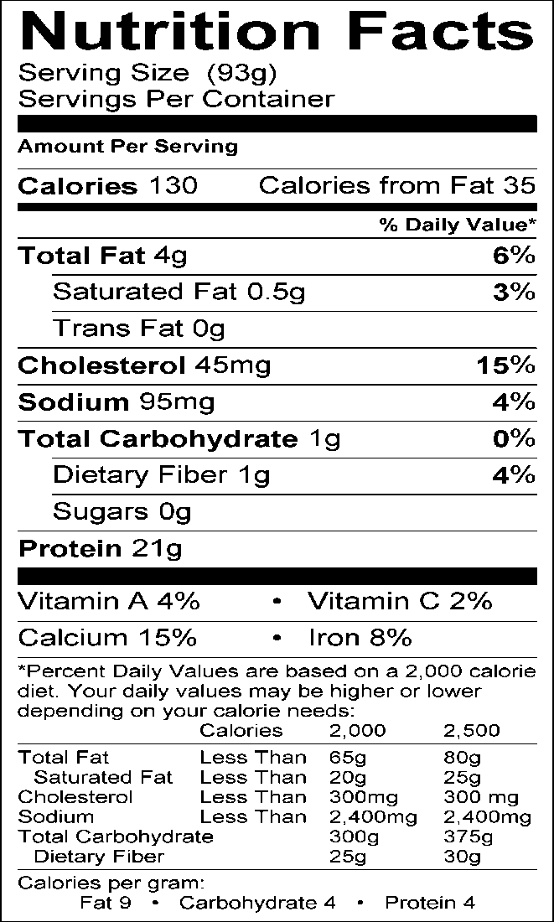
Serving Information Makes approximately eight 4-oz. servings (93 g each)

Ingredients
2 lbs. mild white fish fillets (orange roughy, sole, perch, etc.) cut into eight 4 oz. pieces
1/3 c. sliced almonds
1½ Tbsp. reduced-fat margarine, melted 1 Tbsp. lemon or lime juice
1 Tbsp. grated lemon or lime rind (optional) 1 tsp. Worcestershire sauce
1 tsp. paprika
¼ tsp. pepper Cooking spray

Equipment
11” x 15” baking pan Small mixing bowl Mixing spoon
Grater
Measuring cups and spoons Spatula for serving

Directions
- Preheat oven to 400°F. Coat an 11” x 15” baking pan with cooking spray.
- Pat fish dry with paper towels. Arrange in a single layer in baking pan.
- In a small bowl, mix almonds, margarine, lemon juice, lemon rind, Worcester- shire sauce, paprika and pepper.
- Top fillets with above mixture, spreading evenly.
- Bake 12-15 minutes or until fish flakes easily.

Source: Dining with Diabetes WVUES, 2000-present

Talking Points

Almond Crusted Fish

- A good rule of thumb to use when cooking fish is 10 minutes per inch of thickness.

- This recipe is an excellent source of lean protein, has only 1 gram of saturated fat, and is low in carbohydrate.

- The American Heart Association recommends 2-3 servings of fish per week for heart health. Best sources of omega-3 fatty acids include fatty fish like salmon, albacore tuna, mackerel, sardines, and lake trout.

- Milder types of fish such as perch, sole, orange roughy, etc. are recommended for this recipe. These types of fish contain less omega-3 fatty acids than the fatty fish listed above.

- Sole was used in the nutritional analysis of this recipe.

- Almonds are an excellent source of Vitamin E. Almonds are also a good source of protein, fiber, and B vitamins. They may be substituted with any other type of nut or seed such as pecans or sesame seeds.

- Almonds contain unsaturated fat which is considered heart-healthy if used in moderation. In fact, eating one ounce of almost any type of nuts (with the exception of coconut) 5 times per week may reduce the risk of heart disease. Be sure the nuts have not been previously salted or roasted in oil.

- Boneless skinless chicken breasts can also be used in this recipe instead of fish.

- When grating lemon rind do not grate too deeply into the white under- layer (pith) of the peel. The pith is very bitter and will impart an unpleasant flavor to the fish.

Baked Pork Chops 4

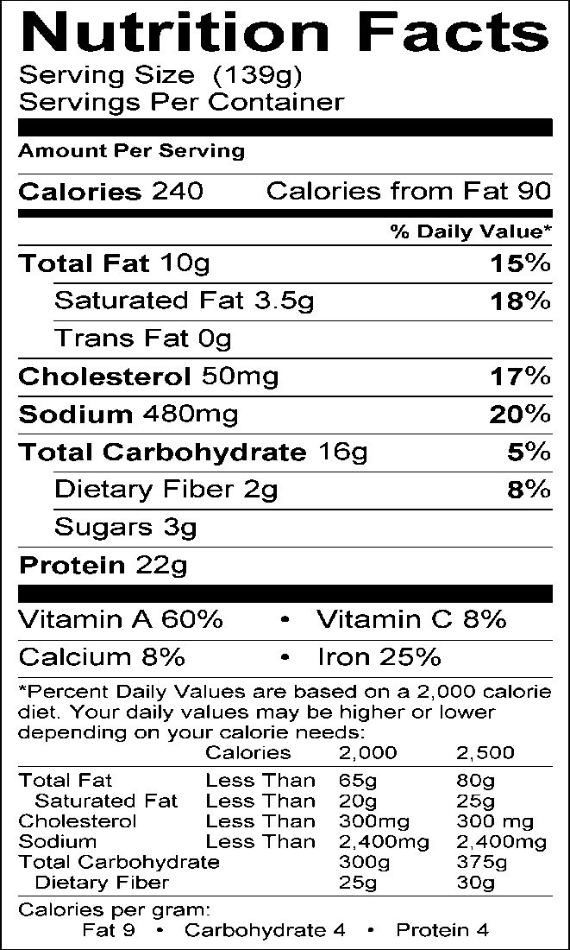
Serving Information
Makes 4 servings
(4 oz. each or 139 g)
Hot & Spicy Seasoning
¼ c. paprika
2 tsp. chili powder
2 Tbsp. dried oregano, crushed 1 tsp. black pepper
1 tsp. garlic powder
½ tsp. cayenne pepper
½ tsp. dry mustard
Mix all ingredients together. Store in
airtight container.

Ingredients
4 lean boneless pork chops, 4 oz. each 1 egg white
¼ c. evaporated skim milk or skim milk
½ c. cornflake crumbs (higher in sodium
than plain bread crumbs)
1 Tbsp. Hot & Spicy Seasoning Cooking spray

Equipment Sharp knife Shallow bowl Plastic bag
Baking dish 9” x 13” Measuring cups and spoons

Directions
- Trim all fat from chops and discard.
- Beat egg white with evaporated skim milk. Place chops in milk mixture. Let stand for 5 minutes, turning chops once.
- Mix together cornflake crumbs and Hot & Spicy Seasoning in plastic bag.
- Remove chops from milk mixture. Drop in plastic bag and shake to coat thoroughly.
- Spray a 9” x 13” baking pan with cooking spray. Place chops in pan. Sprinkle remaining crumb mixture on chops.
- Bake at 375°F. for 15 minutes. Turn chops over; bake 5-10 minutes more or until the centers of the chops reach the safe internal temperature recommended by USDA.

Source: Dining with Diabetes WVUES, 2000-present

5

Talking Points

Baked Pork Chops

Spicy seasoning mixtures add a new taste to recipes that have the salt reduced or eliminated. The Hot & Spicy Seasoning mixture keeps well and can be used on many foods such as chicken, fish, beef, and salads.

- Modern pork production has reduced the amount of fat in the meat. The leanest cuts of pork include the tenderloin, sirloin chops, loin roast, and top loin chops. Pork is a good source of protein, iron, zinc, and B vitamins. When used in small portions and when the leanest cuts are chosen, pork can be part of a healthy diet.

- Evaporated skim milk gives a nice flavor to the coating for the pork chops. Regular skim milk can also be used.

- Cornflake crumbs are tasty and somewhat salty. No additional salt is needed when the chops are breaded in this mixture.

- This recipe is excellent with chicken, turkey cutlets, or fish. If fish is used, reduce baking time to 15 minutes total.

Beef Stew 6
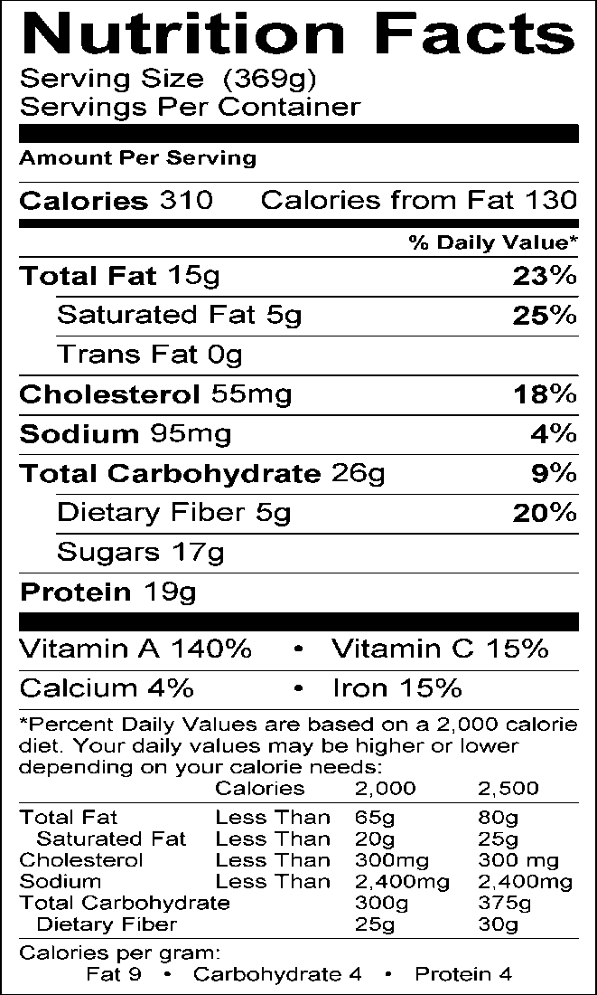
Serving Information Makes approximately 2 servings (one serving = 1 c. with 3-4 ounces of beef)

Ingredients
1 tsp. canola oil
1/3 c. chopped onion
1 garlic clove, minced
1 small carrot, cut into 1” pieces
½ pound (8-oz.) of lean stew beef, cut into 1-inch cubes
1 c. low-fat, low-sodium beef broth
¼ tsp. paprika
¼ tsp. pepper
1 small pear and 1 small apple, unpeeled and chopped into 1-inch pieces

Equipment
Stockpot with lid
Cutting boards and knives
Measuring cups and spoons
Mixing spoons

Directions
- Heat the oil in stockpot over medium-high heat.
- Add the onion and garlic and sauté for 5 minutes.
- Add carrots and sauté for another 5 minutes.
- Add the meat and brown.
- Drain off any accumulated fat.
- Add the broth, paprika, and pepper.
- Bring to a boil over high heat.
- Reduce heat and simmer uncovered for 30 minutes.
- Add the apple and pear chunks; cover.
- Cook over low heat for 15-20 minutes until the apples and pears are soft, but not mushy.

Source: Dining with Diabetes WVUES, 2000-present

7

Talking Points

Beef Stew

The pears and apples compliment the beef in this hearty dish.

- When preparing this dish, remember the rules to prevent cross
  - -contamination: use separate cutting boards and utensils for fresh produce and raw beef. Also remember to wash hands be- fore and after handling raw meat products.

Broccoli Chicken Bake 8

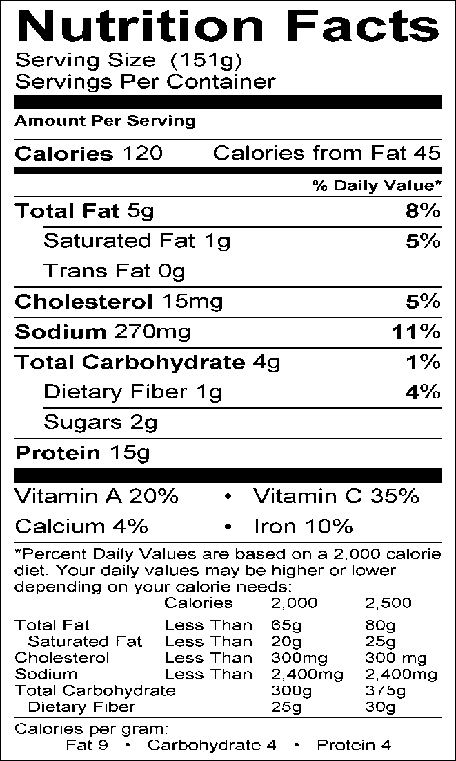
Serving Information
Serves 4
(one serving = ¾ c.)

Ingredients
1 c. chopped, fresh broccoli florets
½ c. chopped cooked chicken (4-oz.)
¼ c. chopped tomatoes (1 small tomato)
¼ c. chopped onions (1 small)
¼ tsp. dried tarragon
1 Tbsp. canola oil
1 c. egg substitute

Equipment
Large skillet or electric frying pan Measuring cups and spoons

Directions
- Sauté broccoli, chicken, tomato, onion and tarragon in oil in a skillet or frying pan over medium heat until broccoli is tender-crisp.
- Pour egg substitute evenly over all
ingredients.
- Cover and cook for 6-8 minutes or until firm on bottom and almost set on top. Cut into 4 wedges to serve.

Source: Dining with Diabetes WVUES, 2000-present

9

Talking Points

Broccoli Chicken Bake

This recipe is easy to prepare and requires little clean-up.

- It is low in fat, carbohydrate, and is a good source of protein.

- Refrigerate any leftovers immediately. Serve within two days. When reheating leftovers, make sure the chicken is heated to the safe internal temperature recommended by USDA.

Broccoli Chicken Frittata 10

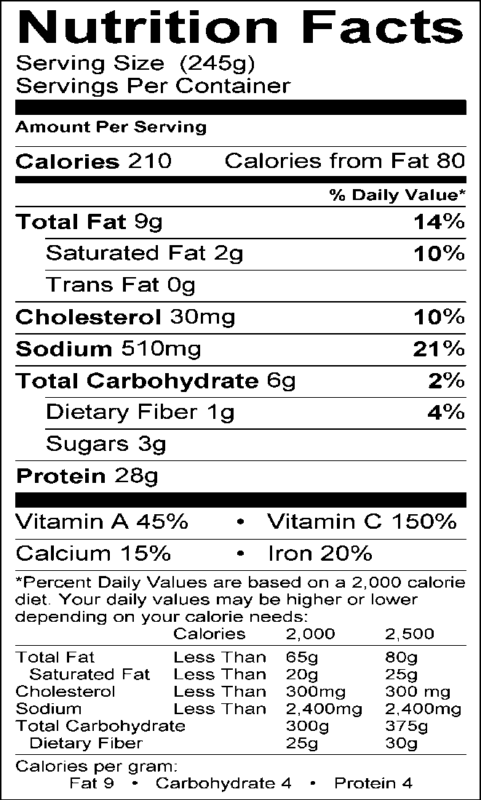
Serving Information Makes approximately 4 servings

Ingredients
2 tsp. olive or canola oil
1 c. finely chopped, fresh broccoli florets
1 c. diced red pepper
1 (6-oz.) boneless skinless chicken breast, cooked and finely diced
¼ c. diced onion
¼ tsp. each dried thyme and oregano
⅛ tsp. black pepper
1/3 c. grated reduced-fat cheddar cheese
2 c. egg substitute

Equipment
Measuring cups and spoons Medium skillet or electric frying pan Spatula

Directions
- In a large skillet, heat oil over medium heat. Add broccoli, red pepper, chicken, onion, thyme, oregano and black pepper, sautéing
- until vegetables are tender and chicken is heated through (about 5-6 minutes).
- Sprinkle grated cheddar evenly over surface of vegetable mixture.
- Pour egg substitute evenly over all ingredients.
- Cover and cook for 8-10 minutes or until firm. Cut into four wedges and serve.

Source: Dining with Diabetes WVUES, 2000-present

11

Talking Points

Broccoli Chicken Frittata

Cheese can be grated ahead of time and brought to class in a zip-top bag. Vegetables can also be chopped ahead of time.

- This recipe is easy to prepare and requires little clean-up.

- It is low in carbohydrate and a good source of protein.

- This recipe calls for pre-cooked chicken breast. Baking or grilling the chicken instead of frying it will keep this dish heart- healthy.

- Refrigerate any leftovers immediately. Serve within two days. When reheating leftovers, make sure the chicken is heated to the safe internal temperature recommended by USDA.

Chicken Breasts with Apricot 12
Ginger Glaze
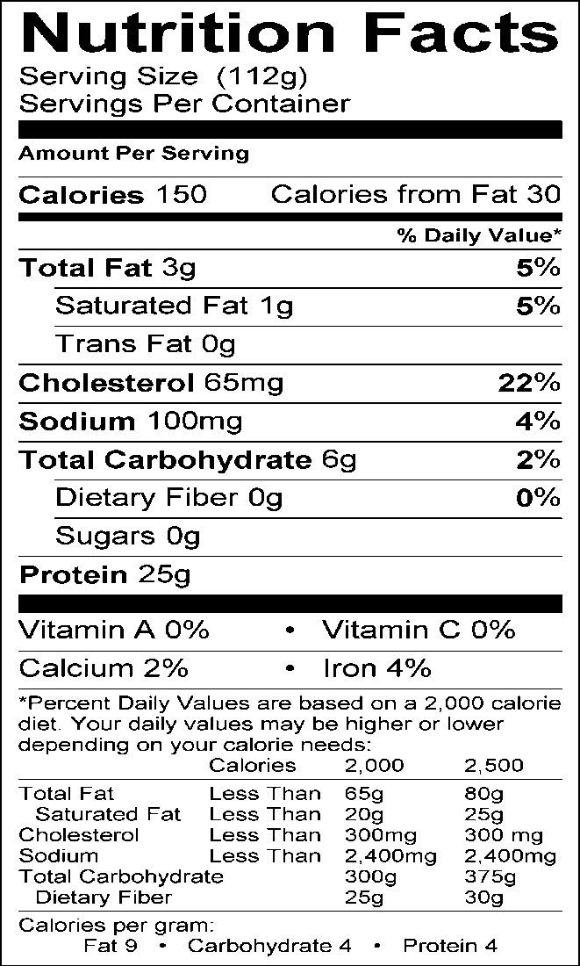
Serving Information
Serves approximately 8 (½ c. or 4 oz. servings)

Ingredients
2 lb. boneless, skinless chicken breasts
(eight, 4-oz. pieces)

Glaze:
1 tsp. canola oil
2 tsp. freshly grated ginger (or ½ tsp. ground ginger)
2 cloves garlic, minced (or ¼ tsp. garlic powder or 1 tsp. bottled pre-minced garlic)
2 Tbsp. red wine vinegar
2 Tbsp. Splenda granular
½ c. sugar-free apricot jam or preserves
2 tsp. reduced-sodium soy sauce
¼ tsp. black pepper
Cooking spray

Equipment
Baking pan (9” x 13”) Small saucepan
Measuring cups and spoons Grater
Spoon

Directions
- Preheat oven to 350°F. Spray 9” x 13” baking pan with cooking spray.
- Coat a small saucepan with cooking spray. Heat the pan to medium, add the ginger and garlic, and cook for one minute. Turn heat to medium-high, add the vinegar and Splenda and bring to a boil. Stir until the Splenda dissolves. Add the apricot jam, soy sauce and pepper. Stir to combine and remove from heat; set aside half of the glaze to be served with cooked chicken (this prevents cross-contamination from the raw chicken).
- Place chicken on baking pan and bake for 20-25 minutes, basting with glaze 2-3 times during the cooking process.
- Spoon remaining glaze over chicken just before serving.
Source: Dining with Diabetes WVUES, 2000-present

13

Talking Points

Chicken Breast with Apricot Ginger Glaze

You can serve the sauce in a bowl on the side, and each person can top their chicken with a small spoonful of sauce. If the sauce is poured over the chicken, the presentation is not as appealing.

- This recipe would also be nice with pork loin chops instead of chicken.

- Using Splenda and sugar-free jam keeps the carbohydrate content of this recipe low, making it more suitable for people with diabetes.

- Peel and freeze fresh ginger prior to grating—it makes grating easier.

- Always keep food safety in mind. Using a meat thermometer is the best way to test poultry for doneness. Bake chicken to the safe internal temperature recommended by USDA.

Cream of Chicken and Rice Soup 14

Ingredients 1 1

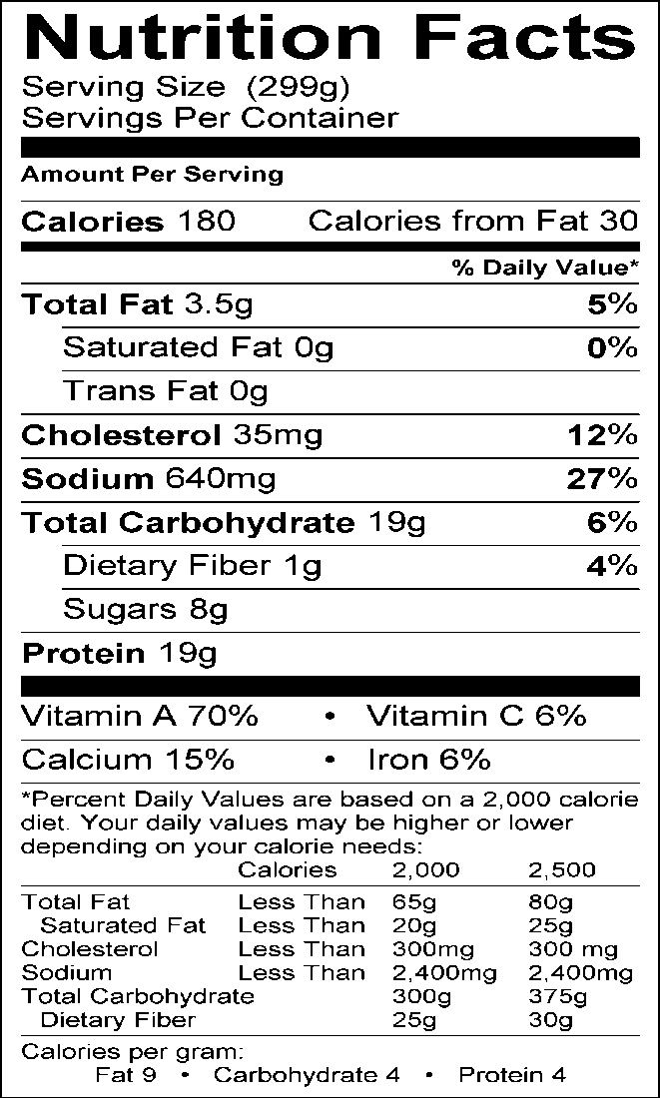
Serving Information Makes approximately eight 1-c. servings

1 onion, diced
2 medium carrots, shredded
2 celery stalks, chopped
1 Tbsp. canola oil
¼ c. all-purpose flour
4 c. reduced-sodium chicken broth
1 c. cooked brown rice
1 lb. boneless skinless chicken breast, cooked and diced
⅛ tsp. black pepper
1½ c. evaporated skim milk (can also use skim milk but soup will be thin)

Equipment
Measuring cups and spoons
Large pot or saucepan
Large spoon
Ladle

Directions
- In a large pot or saucepan, sauté the onion,
carrot, and celery in oil until tender, about 3-5 minutes.
- Gradually add flour, stirring until blended (mixture will be a very thick paste- like consistency). Gradually add broth, stirring constantly until flour is dissolved.
- Stir in the rice, chicken, and pepper.
- Bring to a boil over medium heat; cook and stir for 2 minutes or until thickened.
- Stir in milk; cook 3-4 minutes longer but do not bring to a boil.

Source: Dining with Diabetes WVUES, 2000-present

15

Talking Points

Cream of Chicken and Rice Soup

- For a meatless dish, replace the chicken broth with vegetable broth and replace the cooked chicken with cubed firm tofu.

- This recipe calls for pre-cooked chicken breast. Baking or grilling the chicken instead of frying it will keep this dish heart-healthy.

- Chop vegetables and chicken breast ahead of time and store separately in zip-top bags.

- Rice must be cooked ahead of time.

- Canned soups generally have 800-1000 mg of sodium per one cup serving. This soup has less than half that amount and therefore is much more appropriate for people with diabetes, kidney disease, heart disease, or high blood pressure.

- Canned cream soups are generally very high in saturated fat. Using evaporated skim milk helps maintain the desired creamy texture with- out adding any fat.

- One cup of this soup provides 20% of the daily requirement for calcium and 140% of the daily requirement for Vitamin A.

- Boiling the soup after the milk has been added may cause the soup to separate making the texture grainy/gritty.

- This soup can be frozen for up to 3 months in a refrigerator freezer or 6 months in a chest freezer.

Healthier Swiss-Steak 16

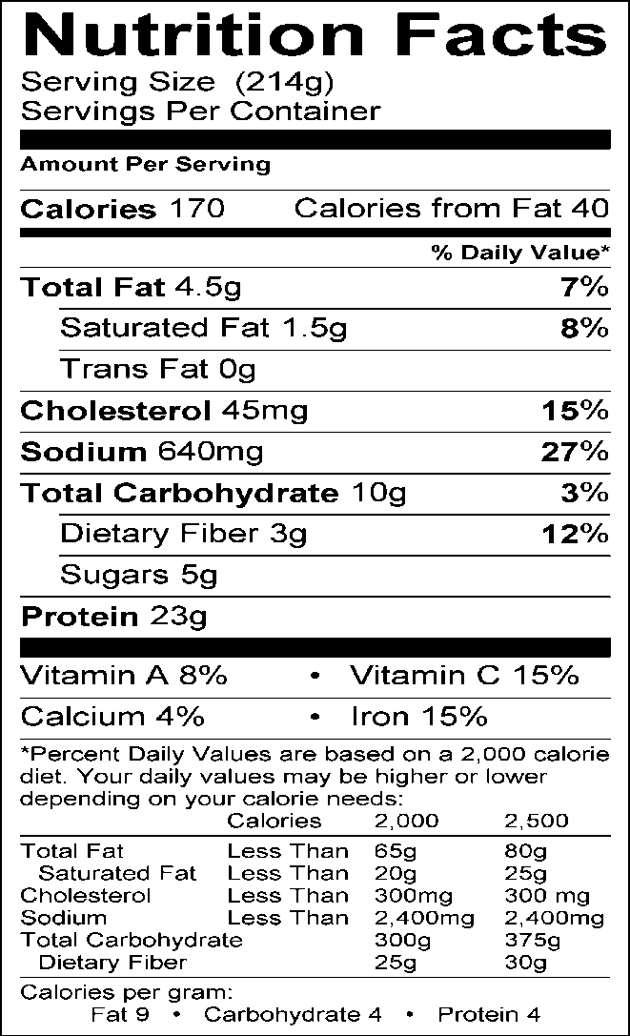
Serving Information Makes approximately 2 servings

Ingredients
½ lb. round steak, trimmed of visible fat and bone
⅛ tsp. black pepper
1 c. tomato sauce, no salt added
1 Tbsp. instant onion flakes
¾ c. sliced celery
1 (4-oz.) can sliced mushrooms and liquid
½ Tbsp. dried parsley flakes

Directions
- Trim all visible fat from meat. Cut in serving size pieces. Sprinkle with pepper.
- Place in baking dish. Pour tomato sauce over meat. Cover with plastic wrap and marinate in refrigerator overnight.
- The next day, sprinkle on onion flakes and
- celery. Add mushrooms and liquid. Top with parsley flakes.
- Bake, covered with foil (shiny side down) at 350°F. for 1½ hours or until steak is tender.

Source: Dining with Diabetes WVUES, 2000-present

17

Talking Points

Healthier Swiss-Steak

This recipe is fairly high in sodium. To reduce sodium, use low sodium tomato sauce and fresh mushrooms. Take time to trim all the fat. Each tablespoon of fat equals 45 calories. The tomato sauce is acidic and helps tenderize the meat.

- This dish can be made ahead of time and reheated easily.

- You can substitute green peppers for fresh mushrooms if desired. You can also add more onions to increase the flavor of the dish.

Hearty Vegetable Bean Soup 18

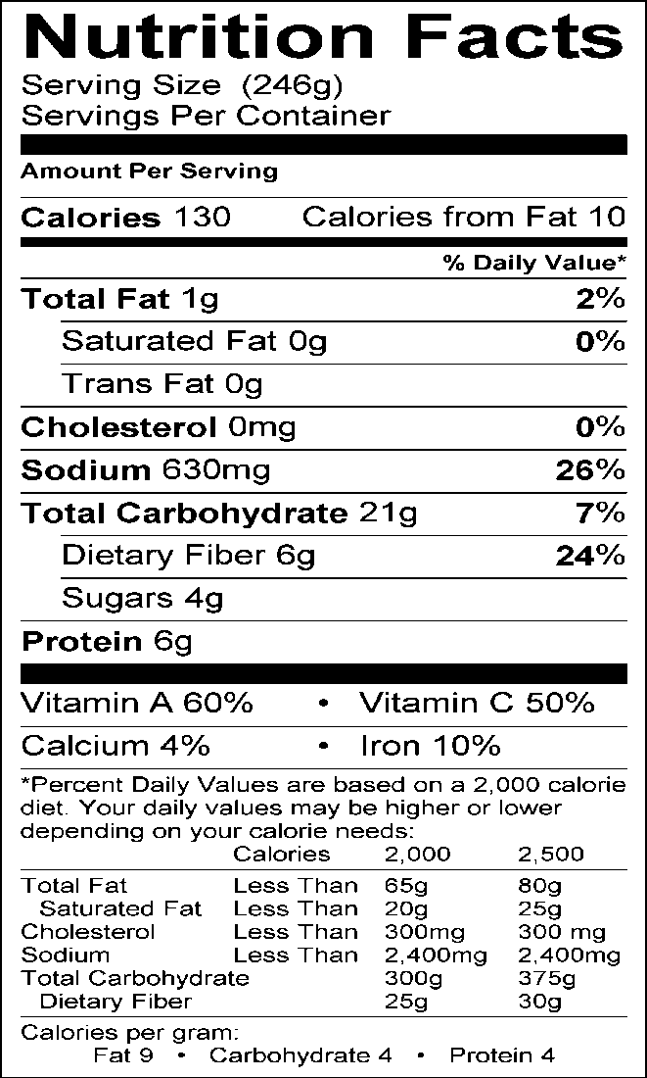
Serving Information Makes approximately ten 1-c. servings

Ingredients
2 tsp. olive or canola oil
1 c. each diced onions, red pepper and carrots
2 cloves garlic, minced (or ¼ tsp. garlic powder or 1 tsp. bottled pre-minced garlic)
1 tsp. each dried thyme, oregano and parsley 3 c. reduced-sodium broth (can be beef, chicken or vegetable)
1 c. tomato sauce, no salt added
2 (15.5-oz.) cans pinto beans, drained and rinsed
1 tsp. brown sugar
¼ tsp. black pepper

Equipment
Measuring cups and spoons Large saucepan or stockpot Strainer
Mixing spoon Ladle

Directions
- Heat oil in a large soup pot over medium heat. Add onions, red pepper, carrots, garlic, thyme, oregano, and parsley. Cook and stir for 5 minutes, or until vegetables begin to soften. Add all remaining ingredients. Bring to a boil.
- Reduce heat to medium-low and simmer, covered for 15-20 minutes until vegetables are tender.

Source: Dining with Diabetes WVUES, 2000-present

Talking Points

Hearty Vegetable Bean Soup

Any kind of beans can be substituted for the pinto beans in this recipe.

- Do not use garlic salt in this recipe. It will only add unnecessary sodium to the soup.

- To save time, the vegetables can be chopped ahead and placed in a zip-top bag. The beans can be drained, rinsed and stored in an airtight container in the refrigerator before using.

- This soup can be pureed in a food processor or with an immersion blender if a creamier consistency is desired.

- A serving of this soup is very nutritious providing and pro- vides dietary fiber, Vitamin A, Vitamin C, iron, and protein.

- Canned soups generally have 800-1000 mg of sodium per one cup serving. This soup has less than half that amount and therefore is much more appropriate for people with diabetes, kidney disease, heart disease, or high blood pressure.

Irish Beef Stew
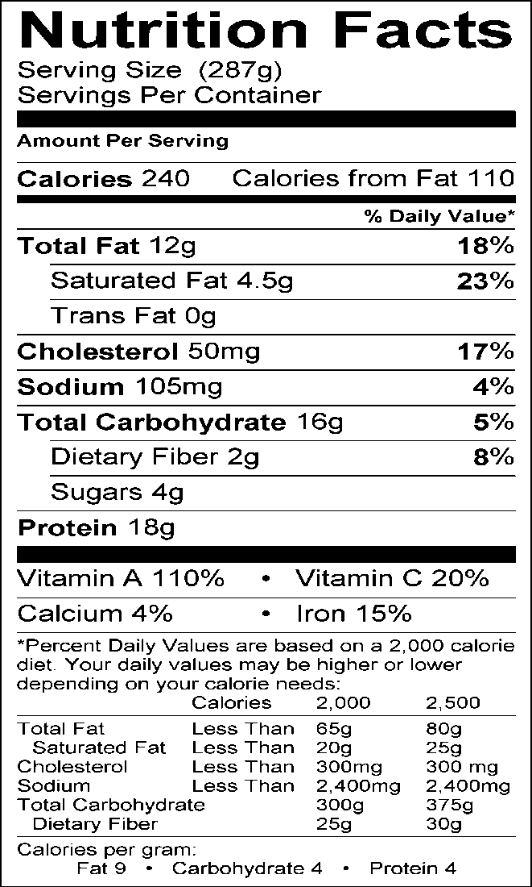
Serving Information Makes approximately eight 1-c. servings

Ingredients
2 tsp. olive or canola oil
1 lb. lean stewing beef, cubed
2 Tbsp. all-purpose flour
1 medium onion, chopped
2 cloves garlic, minced (or 1/4 tsp. garlic powder or 1 tsp. bottled pre-minced garlic)
2 c. sliced carrots
1 c. sliced celery
2 medium potatoes, peeled and diced
1 (6-oz.) can tomato paste
4 c. reduced-sodium beef broth
2 Tbsp. cornstarch
½ c. cold water

Equipment
Dutch oven or large pot
Measuring cups and spoons
Large spoon for stirring
Large zip-top bag
Ladle
Potato peeler

Directions
- Heat oil in a Dutch oven or large pot over medium-high heat.
- In a large zip-lock bag, add flour and beef cubes. Toss to coat, shaking off the excess. Sauté beef cubes until browned on all sides. Remove from the pot, and set aside.
- Add the onion, and garlic to the pot, and cook stirring constantly until onion is tender, about 3 minutes.
- Return beef to the pot, along with carrots, celery and potatoes. Stir in tomato paste and beef broth. Bring to a boil, reduce heat and simmer, covered for 1 hour. Mix together the cornstarch and cold water. Stir into the stew, and simmer until thickened.

Source: Dining with Diabetes WVUES, 2000-present

Talking Points

Irish Beef Stew

This recipe will yield approximately 20 appetizer or sample- sized servings.

Lemon Chicken 22

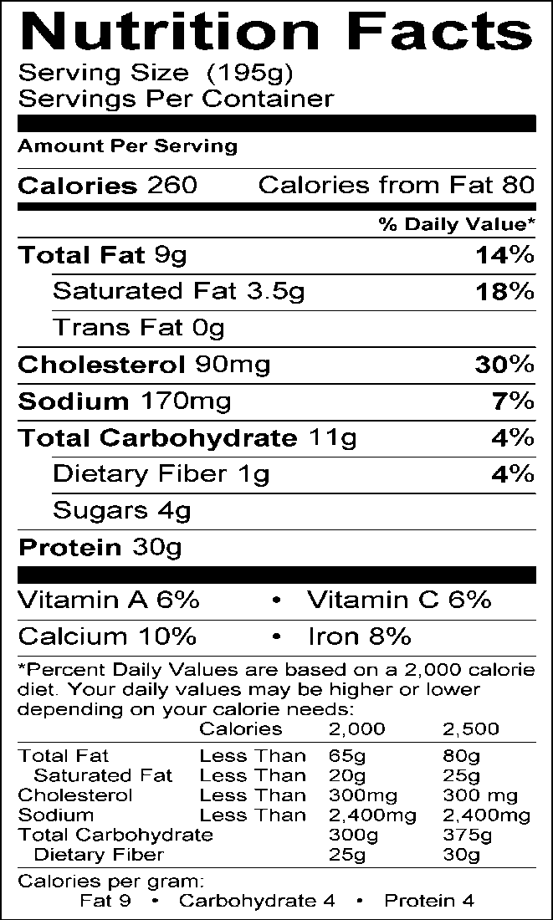
Serving Information
Makes 2 servings

Ingredients
2 (4-oz.) boneless, skinless chicken breasts halves, cooked
2 tsp. lemon juice
1/3 c. light sour cream
1/3 can low-fat, reduced sodium cream of mushroom soup
4 saltines, crushed
Parsley and lemon for garnish (optional)

Directions
- Place chicken in an 8” x 8” casserole dish. Sprinkle with lemon juice.
- Mix sour cream and soup; spread over mixture.
- Sprinkle crushed crackers crumbs on top.
- Bake in 350°F. oven until brown and bubbly; about 30 minutes.
- Garnish with parsley and lemon slices.

23

Talking Points

Lemon Chicken

Using light products reduces the fat content in recipes.

Lemon Steamed Fish 24

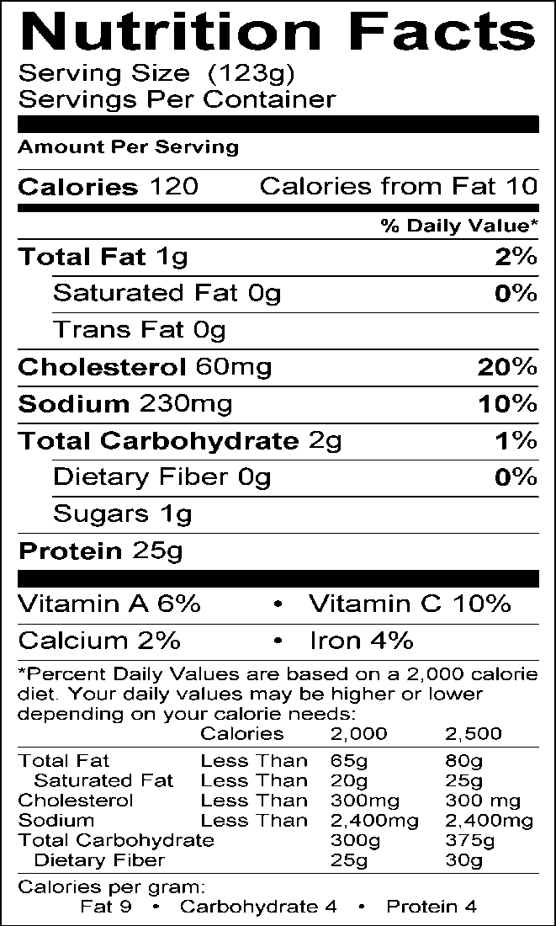
Serving Information Serves approximately eight 4-oz. servings

Ingredients
2 lbs. cod, halibut or other mild white fish cut into 8 (4-oz.) fillets
½ c. onion, finely chopped
¼ c. finely chopped fresh parsley (or 1 Tbsp. dried)
1 Tbsp. grated lemon rind 1½ tsp. dried dill
½ tsp. salt
½ tsp. paprika
¼ tsp. pepper
1 Tbsp. lemon juice

Equipment Baking sheet
Foil
Measuring cups and spoons Grater

Directions
- Preheat oven to 400°F.
- Center each fillet on a 12-inch square of foil. Sprinkle with onion, parsley, lemon rind, dill weed, paprika, salt, pepper and lemon juice.
- Fold foil over fillet to make a packet; pleat seams to securely enclose the packet and place on baking sheet.
- Bake for 15-20 minutes until fish is opaque.

Source: Dining with Diabetes WVUES, 2000-present

25
Talking Points
Lemon Steamed Fish

- This recipe is easy to prepare with little clean-up. The vegetables can be chopped ahead of time.

- This dish is also low in fat and high in protein.

- Fish contain essential oils called omega-3 fatty acids. The word “essential” means that our bodies do not make the nutrient so we must get these oils from foods. Very few foods, other than fish, are rich in omega-3 fatty acids.

- The dill adds color and complements the lemon flavor of this dish.

- When grating lemon rind do not grate too deeply into the white under layer (pith) of the peel. The pith is bitter and will impart an intense bitterness to the fish.

- Many people say they do not like fish, but often reasons are because the fish was of poor quality or not cooked properly. Knowing tips for purchasing can make a difference.

- Look for supermarkets that offer a fresh variety of fish. Look for specials and always check for quality. When purchasing fresh fish, you might ask what days they are delivered.

- Note the smell of fish when purchasing. If it smells “fishy”, then it’s not fresh.

- Fresh fish appears firm and the eyes should be shiny. Fillets should be firm and moist. Fresh fish smells like seaweed but never smells “fishy”. Refrigerate fresh fish immediately. Place fillets or whole fish in ice (crushed or cubed) in a large container and cover loosely with plastic wrap. Store in the coolest place in refrigerator.

- Wrappings from fresh or frozen fish will develop an unpleasant odor quickly if left at room temperature. Store tightly sealed and away from other foods in the freezer until time for garbage pickup.

Mini Meatloaves with Barbecue Sauce 26
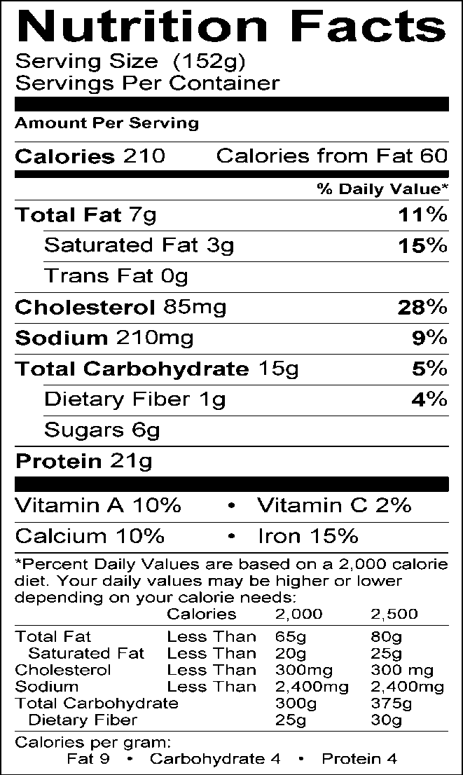
Serving Information Makes approximately 12 servings

Ingredients
2½ lbs. extra lean ground beef 1 c. quick oats
¾ c. minced onion
½ c. dry bread crumbs or cracker crumbs 1 (12-oz.) can evaporated skim milk
2 eggs
2 Tbsp. chili powder
½ tsp. garlic powder
¼ tsp. salt
¼ tsp. black pepper
6 Tbsp. barbecue sauce

Equipment
Large mixing bowl
Mixing spoon
12-cup muffin pan
Measuring cups and spoons

Directions
- Preheat oven to 375°F. In a large bowl combine all ingredients except the barbecue sauce. Mix until ingredients are just combined. (Using your hands works best but thoroughly wash hands before and after mixing).
- Divide mixture evenly among each muffin cup, pressing mixture lightly.
- Spoon approximately 1½ tsp. barbecue sauce over each muffin.
- Bake for 30-35 minutes or until centers reach the safe internal temperature recommended by USDA.

Source: Dining with Diabetes WVUES, 2000-present

27

Talking Points

Mini Meatloaves with Barbecue Sauce

Over mixing the ingredients will make the meatloaf dry and tough. Mix just until ingredients are evenly distributed. Using your hands is often easier than using a spoon.

- Try adding diced celery, peppers, or shredded carrot to the mixture for variety in flavor and texture.

- The eggs will help bind the mixture and keep the meatloaves from crumbling when serving.

- Using extra lean ground beef makes these meatloaves lower in fat and calories and higher in protein. A serving of this meat- loaf provides 24 grams of high quality protein and 6g of total fat. Compare that to a traditional serving of meatloaf (the same size) which provides 16 grams of protein and 12 grams of total fat.

- Using the muffin pan helps control portion size.

- The brand of barbecue sauce does not matter. Use whatever kind you like or have on hand. Some stores carry reduced- sodium barbecue sauce which will help further reduce the sodium content of the recipe. Diabetics should also check the carbohydrate content of the sauce.

One Dish Soup 28

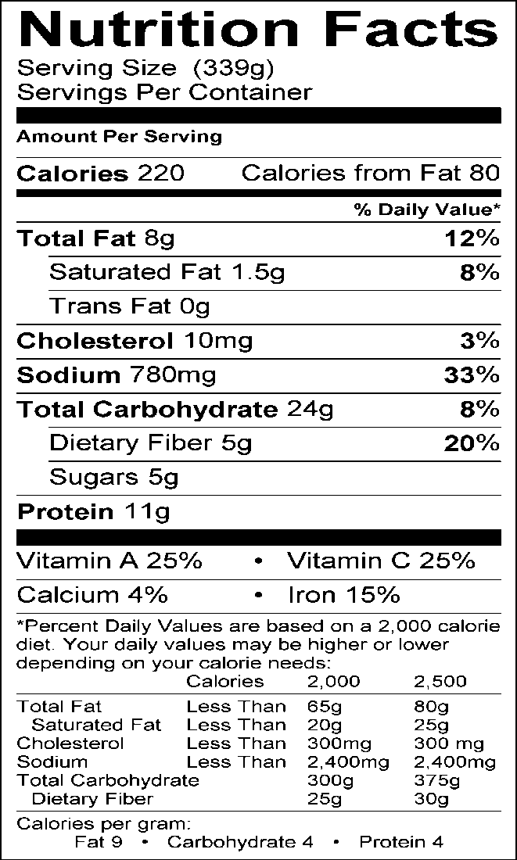
Serving Information Makes approximately four 1-c. servings

Ingredients
2 Tbsp. olive oil
2 green onions, chopped, white and green parts 1 c. diced unpeeled potato
1 (14½-oz.) can no-salt added tomatoes, chopped with juice
1 (14-oz.) can low-sodium chicken broth
½ tsp. dried oregano
¼ tsp. salt (may omit)
¼ c. orzo (small rice shaped pasta)
1 (6-8-oz.) can pinto beans, drained and rinsed (no salt added if possible)
4 oz. 97% fat-free ham, diced
2 c. diced zucchini or yellow squash

Equipment
Medium saucepan or soup pot Measuring cups and spoons Soup ladle
Heat resistant cups for serving

Directions
- Add oil to a medium saucepan or soup pot; add onions and potatoes. Sauté over medium heat for 5 minutes.
- Stir in tomatoes, broth, oregano, and salt; bring to a boil.
- Add pasta and simmer over medium heat, uncovered for 10 minutes or until pasta is cooked through.
- Add beans, ham, and squash; simmer over low heat for 10 minutes, stirring occasionally, and adding water if mixture becomes too thick.

Source: Dining with Diabetes WVUES, 2000-present

29

Talking Points
One Dish Soup

- When purchasing ham, go to the deli or meat department and ask them to slice pieces of their leanest ham approximately ¼ inch thick.

- This soup is very hearty, colorful, and can serve as a full meal. It provides a good source of fiber and it is a great dish for cold days. The soup tastes even better the second day.

- If you do not have green onion, you may substitute 1/3 c. yellow onion.

- The unpeeled potatoes and beans provide a good source of fiber.

- Pinto beans are a legume which is rich in soluble fiber. Soluble fiber slows down the digestion of carbohydrates and may help curb the rise in blood sugar levels.

- Legumes may also reduce absorption of cholesterol from other foods in the same meal. They are a great source of protein (meat substitute) with no saturated fat. However, beans are not a complete source of protein by themselves. For complete protein, beans need to be eaten with a grain such as rice or pasta. Dairy products are complete protein foods.

- You can lower the sodium content considerably by rinsing beans under water.

- Remember olive oil is a good source of monounsaturated fat which helps protect against heart disease. Although the fat content of olive oil is similar to that of other fats, it is a better alternative because it is a healthier type of fat.

- Orzo is rice-shaped pasta that can be used in many different dishes. In Italian, orzo means “barley”. Orzo is wonderful to use in main dishes such as soup or poultry/seafood salads.

- Zucchini and yellow squash are low in calories and are also filling.

Oven-Fried Parmesan Chicken 30
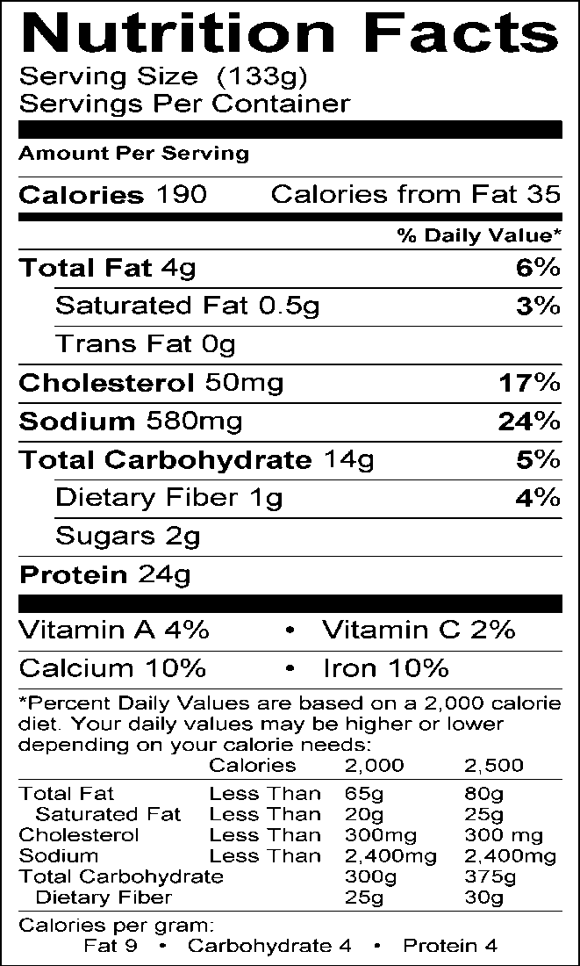
Serving Information Makes approximately 2 servings (one serving = 3-4 oz. of chicken)

Ingredients
1 (6-8 oz.) boneless skinless chicken breast, cut into strips
¼ c. nonfat plain yogurt
¼ c. bread crumbs
1 Tbsp. grated Parmesan cheese
½ Tbsp. flour
¼ tsp. paprika
Pinch of cayenne pepper Cooking spray

Equipment Cookie sheet Medium bowl Small bowl
Measuring cups and spoons

Directions
- Preheat the oven to 450°F. And spray
cooking sheet.
- Place chicken strips in yogurt and refrigerate
while preparing the rest of the ingredients.
- In small bowl, mix remaining ingredients.
- Coat each piece of chicken with yogurt and dredge in crumbs mixture, pressing down on both sides to get a coating of crumbs.
- Place chicken strips on cookie sheet, spray lightly with cooking spray.
- Bake for 15-20 minutes or until chicken is tender and juice runs clear, or to the safe internal temperature recommended by USDA.

Source: Dining with Diabetes WVUES, 2000-present

31

Talking Points

Oven-Fried Parmesan Chicken

This recipe is quick and easy. It is also an easy finger food for children.

- Make sure you are using skinless chicken since the skin is a significant source of fat.

- Make sure to check for dates on packaged meats.

Parmesan Coated Filets 32

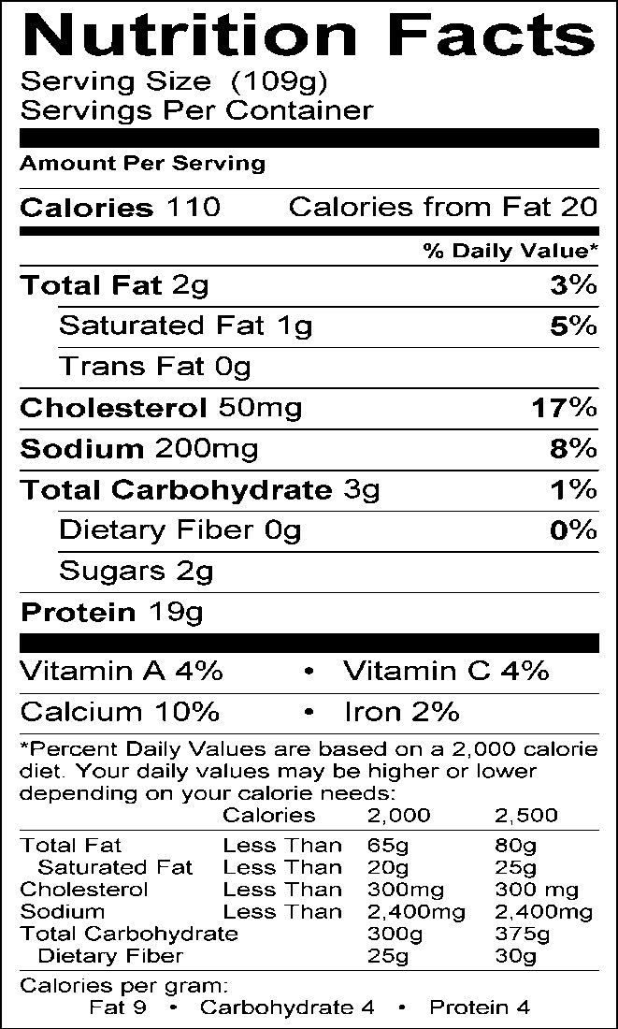
Serving Information Makes approximately 2 servings (one serving = 4 oz. fish)

Ingredients
½ lb. of flounder or other light/mild white fish filets
¼ c. low-fat plain yogurt
1 Tbsp. grated Parmesan cheese
½ Tbsp. Dijon mustard
½ Tbsp. fresh lemon juice
½ tsp. prepared horseradish, drained Cooking spray

Equipment Broiler pan Foil
Small bowl
Measuring cups and spoons

Directions
- Preheat the broiler, cover broiler pan
with foil and spray with cooking spray.
- Arrange fish on the broiler pan.
- In a small bowl, combine the yogurt, cheese, mustard, lemon juice, and horseradish.
- Spread the mixture on both sides of fish.
- Broil about 8 inches from the heat, turning once, for about 6 minutes, or until the fish flakes easily with a fork.

Source: Dining with Diabetes WVUES, 2000-present

33
Talking Points
Parmesan Coated Filets

- This dish is easy to prepare and low in fat.

- Parmesan is high in fat, but because it is so flavorful, you only need to use a small amount.

- The low-fat yogurt helps to keep the fish moist and adds calcium.

- The lemon juice, mustard, and horseradish are a nice compliment to the fish. Experiment with other seasonings you enjoy (lime, lemon, dill, pepper, etc.).

- Fish is a good source of omega-3 fatty acids which are thought to offer protection against heart disease.

- Many people say they do not like fish, but it’s because the fish was poor quality or not cooked properly. Knowing tips for purchasing can make a difference.

- Look for supermarkets that offer a fresh variety of fish. Look for specials and always check for quality. When purchasing fresh fish, you may ask what days they are delivered.

- Note the smell of fish when purchasing. If it smells “fishy”, then it is probably not fresh. Some fish are milder than others.

- Fresh whole fish appears firm and the eyes should be shiny. Fillets should be firm and moist. Fresh fish smells like seaweed but never smells “fishy”. Refrigerate fresh fish immediately. Place fillets or whole fish in ice (crushed or cubed) in a large container and cover loosely with plastic wrap. Store in the coolest place in refrigerator.

- It is never safe to thaw frozen fish or meat at room-temperature. Thaw in the refrigerator or in a plastic bag which is then placed in cold water. During the thawing process, change the water frequently enough to keep the temperature of the water cold. Do not thaw fish or meat in or under hot or warm water.

- Wrappings from fresh or frozen fish will develop an unpleasant odor quickly if left at room temperature. Try storing tightly sealed away from other foods in the freezer until time for garbage pickup.

- Broiling is a good way to cook fish. Be careful not to overcook. As soon as the fish is white and flakes with a fork, it is ready. Serve fish immediately as it cools quickly.

Poncho Villa Omelet 34
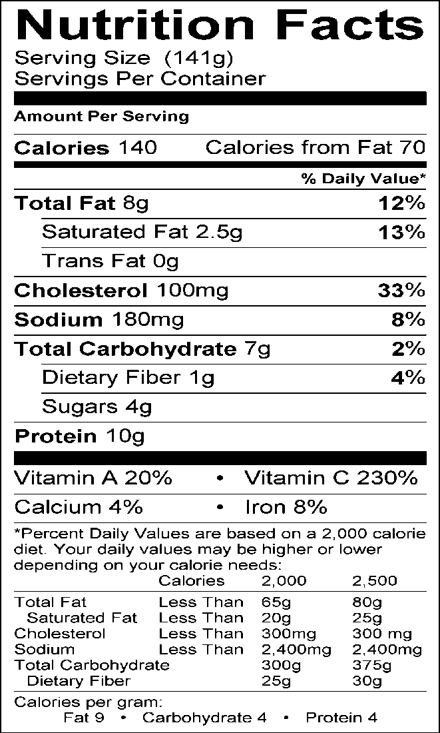
Serving Information Makes approximately 2 servings

Ingredients
½ Tbsp. margarine (can use olive or canola oil)
1 egg plus 4 egg whites
3 Tbsp. water
2 Tbsp. low-fat cream cheese, softened
½ c. (4-oz. can) chopped green chilies

Directions
- Melt margarine or heat oil in omelet pan or skillet.
- Whisk eggs and water together; pour into skillet. Turn heat to medium-low. Using spatula, push egg mixture in one direction allowing the uncooked egg to run onto skillet surface.
- When egg is cooked, dot or spread cream cheese over upper half of omelet. Then cover same half with chilies. With wide spatula, carefully lift and fold other half over the filled side of the omelet.
- Cut in half; serve immediately.

Source: Dining with Diabetes WVUES, 2000-present

35

Talking Points
Poncho Villa Omelet

- Using egg whites instead of whole eggs reduces the cholesterol content of the omelet.

- You can also use egg substitute.

Pork Chops with Maple 36

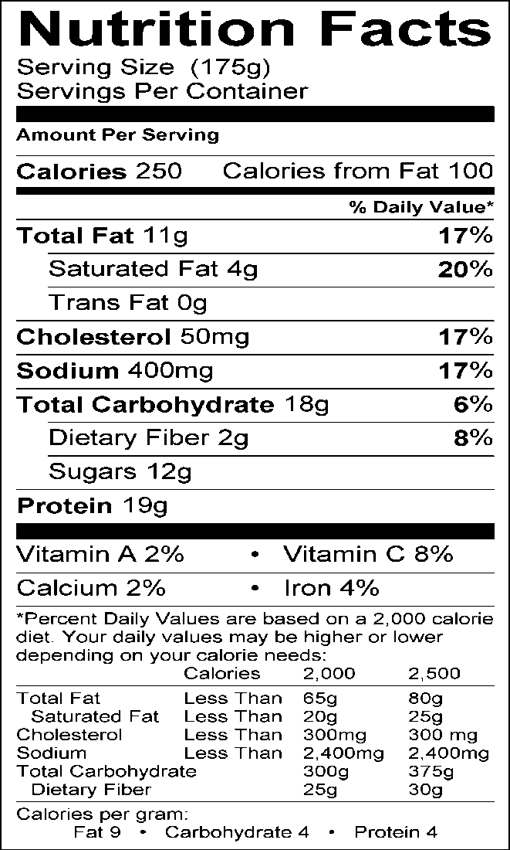
Serving Information Makes approximately eight servings (4-oz. each)

Ingredients
2 lb. boneless pork loin (cut into eight 4-oz. pieces or chops)
2 unpeeled pears, diced
¼ c. maple syrup or pancake syrup (preferably sugar-free)
¼ c. Splenda brown sugar
1 Tbsp. prepared mustard
1 Tbsp. margarine
⅛ tsp. ground cloves
Cooking spray

Equipment
9” x 13” baking dish Medium saucepan Measuring cups and spoons Mixing spoon

Directions
- Preheat oven to 350°F. Spray 9” x 13”
baking dish with cooking spray.
- Place pork chops in baking dish and bake for 15-20 minutes, or until the chops reach the safe internal temperature recommended by USDA.
- Meanwhile place remaining ingredients in a saucepan and cook over medium heat until pears release their juice and mixture is heated through.
- Remove pork from oven and serve topped with glaze.

Source: Dining with Diabetes WVUES, 2000-present

37

Talking Points

Pork Chops with Maple Pear Sauce

The pears should be left unpeeled. This adds more nutrients and fiber to the dish.

- Boneless pork loin chops are leaner than traditional pork chops making this dish heart friendly. Using cuts of meat with the word “loin” and trimming the visible fat usually ensures a lean piece of meat.

- Ground cloves can be substituted with cinnamon or omitted entirely if desired.

- Pears can be substituted with apples if desired. This will increase cooking time by a few minutes as apples will take longer to soften.

- Pears add 2 grams of dietary fiber per serving, increasing the heart healthy nature of this dish while helping to control blood sugar levels.

Potato-Corn Chowder 38

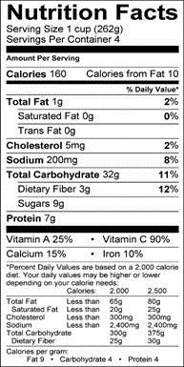
Serving Information Makes approximately 4 servings (one serving = 1½ cups)

Ingredients
½ tsp. olive or canola oil
½ c. chopped green onions, green and white parts
1 small red bell pepper, seeded and chopped
¼ c. chopped celery
1 c. peeled, diced potatoes
1 c. reduced-sodium chicken broth 1 c. frozen whole-kernel corn
3/4 c. evaporated skim milk
½ tsp. dried rosemary
⅛ tsp. black pepper
Salt-free seasoning blend (like Mrs. Dash)

Equipment
Saucepan or soup pot Measuring cups and spoons

Directions
- Heat oil in saucepan over medium-high heat. Add onion, bell pepper, and celery; sauté 5 minutes or until tender.
- Add potatoes and broth; bring to a boil. Reduce heat and simmer, uncovered for about 10 minutes or until potatoes are tender.
- Stir in remaining ingredients; cook for 5-10 minutes or until thoroughly heated. Sprinkle with seasoning blend to flavor without adding salt.

Source: Dining with Diabetes WVUES, 2000-present

39

Talking Points

Potato-Corn Chowder

This has a higher carbohydrate count. Adjust meal accordingly and serve chowder with veggies or low-carbohydrate food.

- This recipe is easy; a convenient “one-pot” meal. It can be made in less than one hour.

- This dish can also be used as part of a complete meal. Try serving with a salad.

- It is low in fat and packed full of Vitamin C because it is loaded with vegetables.

- The potatoes and corn are the main sources of carbohydrate in this dish. To reduce carbohydrates, use less corn or potatoes than what is called for in the recipe.

- Evaporated skim milk is a good item to keep in your kitchen for cooking. It has a long shelf-life and can be used in many different recipes.

- Evaporated skim milk is fortified with Vitamins A and D. It adds a creamy texture that regular milk does not. Also, it will not curdle when warmed like regular milk sometimes can.

- Make sure you are buying skim or fat-free evaporated milk.

Quick Chili 40
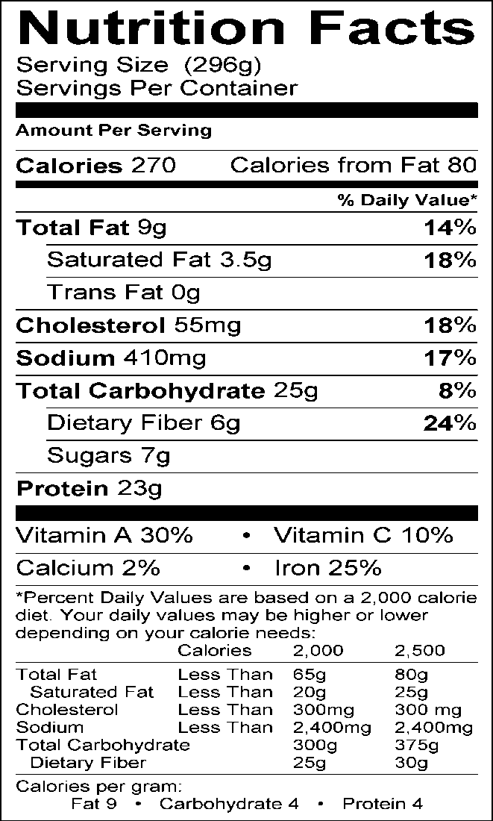
Serving Information Makes approximately six 1-c. servings

Ingredients
1 lb. lean ground beef
1 (15-1/2 oz.) can chili beans (hot if preferred)
1 Tbsp. onion, chopped
2 (14.5-oz.) cans no salt added tomato sauce
1 Tbsp. hot chili powder (optional)

Directions
- Spray saucepan with cooking spray; brown ground beef.
- Turn beef into colander; rinse with hot water. Also rinse saucepan with hot water.
- Return beef to saucepan. Add all other ingredients; heat until mixture bubbles.

Source: Dining with Diabetes WVUES, 2000-present

41

Talking Points

Quick Chili

1. You can substitute ground turkey breast for ground beef. Be sure to select ground turkey breast rather than ground turkey to reduce the fat content.

Spicy Grilled Chicken 42

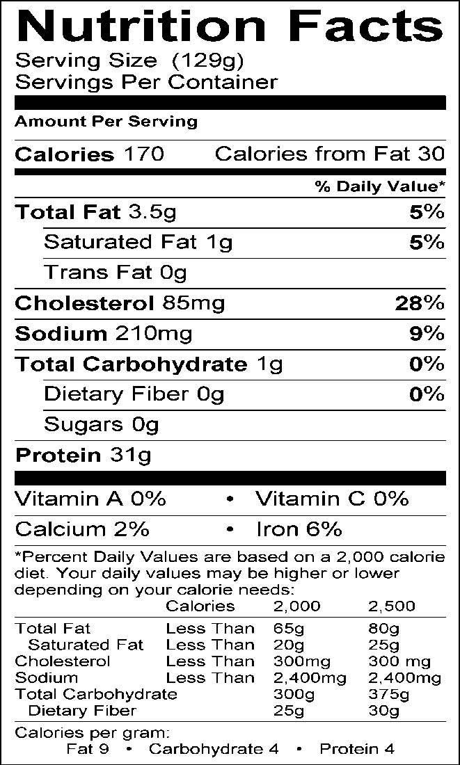
Serving Information Makes approximately 4 servings

Ingredients
2 whole skinless chicken breasts (4 halves)
(about 1 lb.)
½ c. bottled salsa

Equipment Large mixing bowl Measuring cups Tongs
Grill or broiler and grilling tools (or baking dish and cooking spray)

Directions
- About 15 minutes before cooking, measure the salsa into a large bowl.
- Remove any skin and fat from chicken. Place in the salsa and turn with tongs to coat completely. Place bowl in refrigerator until ready to cook chicken.
- Wash tongs and all surfaces that have touched
  - the chicken with hot, soapy water. Wash hands thoroughly with soap and water for
at least 20 seconds.
- When ready to cook, lift chicken pieces from bowl and place on hot grill or broiler pan. Grill or broil about 5 minutes on each side or until the chicken reaches the safe internal temperature recommended by USDA. (Chicken can also be baked. Coat baking dish lightly with cooking spray. Place chicken in baking dish and pour salsa over chicken. Cover tightly and bake at 400°F. for 20 minutes. Test for doneness, as in grilling directions.)
- Wash tongs, bowl, and hands with hot soapy water before touching any other foods. Discard remaining salsa or heat to boiling before using as a sauce. Boiling the marinade will kill bacteria; uncooked marinade can be the source of foodborne illness.
- Serve immediately or refrigerate to use in salads or sandwiches.
Source: Dining with Diabetes WVUES, 2000-present

43

Talking Points

Spicy Grilled Chicken

Germs that are sometimes found on raw chicken can make people very sick. Keep chicken refrigerated until ready to cook to keep germs from multiplying. Freezing and refrigeration do not kill germs. Heat kills germs.

- Use care to wash hands, fingernails, work surfaces, and all tools that have touched raw chicken before touching any other foods. Use hot, soapy water to wash.

- Thoroughly cooked chicken is safe to eat. Chicken breast is low in fat and saturated fat and can be a delicious part of a healthy diet.

- Salsa is usually fat-free and low in added sugar. It makes a quick and delicious marinade for mild foods like chicken, fish, or trimmed lean pork. Try this recipe with fish.

Spinach Lasagna 44
Serving Information
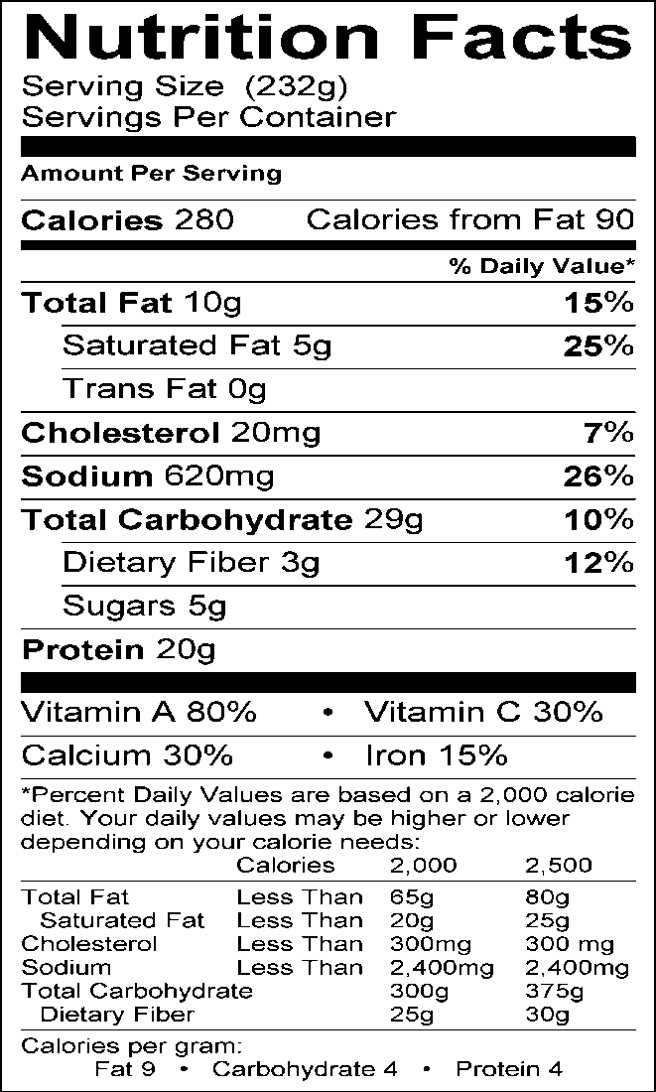
Makes approximately 8 servings

Ingredients
2 tsp. olive or canola oil 2 cloves garlic, minced
1 (8-oz.) can tomato sauce
1 (15-1/2 oz.) can diced tomatoes
¼ tsp. pepper
½ tsp. oregano
1 tsp. olive or canola oil
¼ c. chopped onions
1 (10-oz.) pkg. fresh spinach, washed, stemmed and chopped (or one 10-oz. pkg. frozen chopped spinach, thawed and drained)
8 oz. uncooked lasagna noodles (whole wheat, if possible) 12 oz. 1% fat cottage cheese (or 12 oz. reduced-fat ricotta cheese)
8 oz. shredded part-skim mozzarella cheese
¼ c. grated Parmesan cheese Cooking spray
Equipment
9” x 13” baking dish Saucepan
Skillet Stirring spoons
Measuring spoons Can opener
Sharp knife Rubber scraper
Measuringcups

Directions
- Preheat oven to 375°F. Lightly coat baking dish
with cooking spray.
- In large saucepan over low heat, sauté garlic in 2 teaspoons oil over low heat for 1 minute. Do not let garlic brown. Add tomato sauce, tomatoes, pepper, and oregano. Simmer gently over low heat, uncovered, while preparing other ingredients.
- In large skillet over low heat, sauté onions in remaining 2 teaspoons olive oil, stirring constantly, until onions are transparent but not brown. Add chopped spinach, stirring constantly to break apart, and heat.
- Layer uncooked lasagna noodles, sauce, spinach mixture, cottage cheese, and mozzarella in baking pan. Repeat, using all ingredients, ending with a layer of sauce. Sprinkle top with Parmesan cheese.
- Cover baking dish tightly with foil. Bake for one hour at 375°F. or until lasagna noodles are cooked. (If noodles are cooked before assembling lasagna, bake uncovered and reduce baking time to 25 minutes.)
- Lasagna can be assembled and frozen, uncooked. To prepare lasagna that has been frozen, defrost in refrigerator for 3-4 hours, and then bake, covered, for 1½ hours or more. Lasagna is done when cheese in center is melted, all noodles are cooked, and casserole is very hot all the way to the center.
Source: Dining with Diabetes WVUES, 2000-present

45

Talking Points

Spinach Lasagna

Traditional lasagna is very high in fat because it contains large amounts of cheese. This recipe uses small amounts of reduced-fat cheese. Fat-free cheese can be used, but it does not melt well. Lasagna made with fat-free cheese will be stringier and less creamy than traditional lasagna.

- Look for tomatoes and other vegetables canned with “no added salt.”

- Spinach is high in folate, Vitamin A, and potassium. It makes a healthy and tasty addition to this and many other dishes. Try adding raw spinach leaves to salads and at the very end of stir-fry dishes.

- Olive oil is very good for sautéing garlic and onions. It adds healthy monounsaturated fat and a very traditional flavor to this recipe.

  - Using uncooked lasagna noodles reduces preparation time. Be sure to cover casserole tightly so that the noodles get enough moisture to cook properly.

  - This is a good dish to assemble and freeze for baking later. Be sure to bake frozen uncooked lasagna long enough to heat all the way through the dish. Improper reheating of frozen dishes can result in food spoilage and foodborne illness.

Sweet and Sour Pork 46

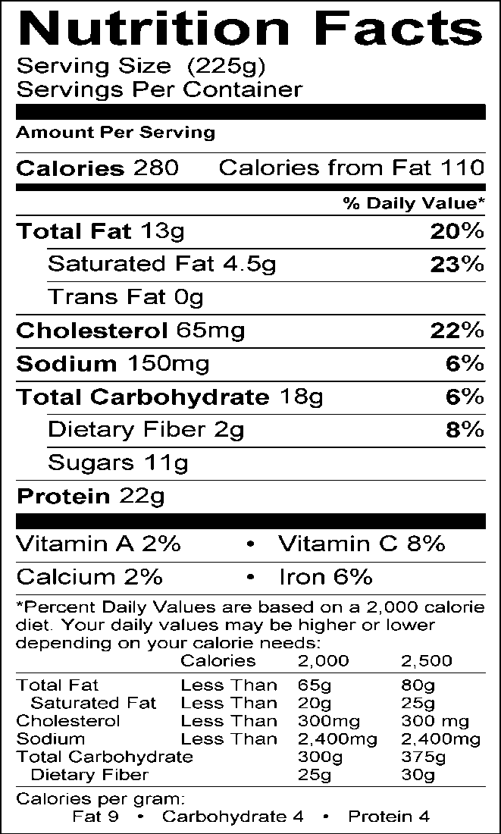
Serving Information Makes approximately 5 servings

Ingredients
1 lb. boneless pork loin cut into ½ inch cubes
1 tsp. vegetable oil
3 small unpeeled apples (Granny Smith preferred), cored and sliced into ½ inch wedges
¾ c. chicken broth (reduced sodium & fat)
1 tsp. brown sugar
3 - 5 packets heat stable artificial sweetener
¼ c. cider vinegar
3 Tbsp. cornstarch
2 Tbsp. low-sodium Worcestershire sauce
¼ tsp. black pepper

Directions
- Heat skillet. Add oil. Brown pork on all sides.
- Add apples, sauté 3 minutes stirring
occasionally.
- Add ½ c. of broth. Reduce heat and
simmer covered for 10 minutes.
- Mix remaining broth with rest of ingredients. Add to skillet.
- Cover and cook over medium heat, stirring constantly until sauce thickens.

Source: Dining with Diabetes WVUES, 2000-present

47

Talking Points

Sweet and Sour Pork

Certain cuts of pork like tenderloin are lean if they are trimmed well. This recipe reduces the amount of fat and cholesterol by combining it with lower fat ingredients like the apples. If Granny Smith apples are not available, substitute other cooking or all-purpose apples. Do not peel apples since the peels contain fiber.

- Small amounts of brown sugar can be used if each serving contains less than one teaspoon of sugar. You may also use brown sugar substitutes.

Sweet and Spicy Stir-Fry 48

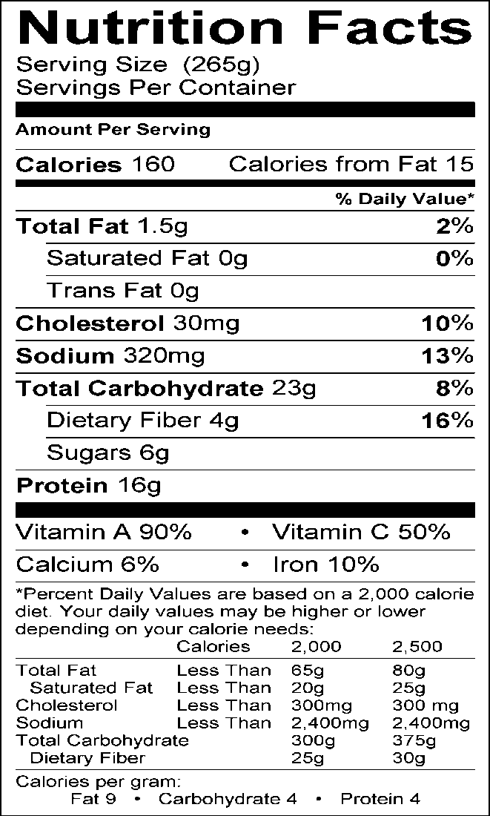
Serving Information
Makes approximately 2 servings (one serving = 1¼ c.)

Ingredients
4 oz. lean pork, chicken, shrimp, or lean beef, sliced into very thin strips
1 small/medium sized carrot, peeled and sliced thin 1 medium potato, unpeeled and diced
1 small onion, diced
½ c. celery, diced
1 c. shredded green cabbage Cooking spray

Sauce
½ Tbsp. cornstarch
¼ c. water (or less)
2 Tbsp. reduced-sodium soy sauce 2 Tbsp. ketchup
1 Tbsp. packed brown sugar

Equipment
Large saucepan or electric frying pan
Small mixing bowl
Grater
Measuring cups and spoons

Directions
- Spray large skillet or electric frying pan with cooking spray. Add meat and cook over medium high heat, stirring frequently, until meat is browned.
- Add carrots and potatoes; cook for 5 minutes, stirring frequently.
- Add celery, onion, and cabbage; cook 5 minutes or until potatoes are tender.
- Mix cornstarch and water in a small bowl, and stir until cornstarch is dissolved.
- Add soy sauce, ketchup and brown sugar to cornstarch and water; mix well.
- Pour sauce over meat mixture and toss well. Reduce heat and simmer for 10 minutes or until sauce thickens.

Source: Dining with Diabetes WVUES, 2000-present

49

Talking Points

Sweet and Spicy Stir-Fry

- Stir-fry recipes are good choices for hurry-up meals. This recipe can be made using a variety of meats and allows you to add several of your own favorite vegetables. It can also be served meatless.

- Using packaged shredded cabbage will save on time.

- If using fresh vegetables, cut ahead of time in consistent size pieces and store in refrigerator until ready to use. Wash cutting board, knife and hands with soap and water before cutting meat last to prevent any possible cross-contamination.

- Meat for stir-fry can be easily cut if it is partially frozen. Cutting across the grain of meat into thin slices reduces cooking time and promotes tenderness.

- There are several types of lean meats to select. Note that for the nutritional analysis here, lean boneless pork chop meat was used. The nutrition content can vary considerably depending on the type of meat used. The difference will affect the fat content more so than the carbohydrate content.

- It is never safe to thaw frozen meat at room-temperature. Thaw meat in the refrigerator or in a plastic bag which is then placed in old water. During the thawing process, change the water frequently enough to keep the temperature of the water cold. Do not thaw meat in or under hot or warm water.

- Keep sodium as low as possible by using reduced-sodium soy sauce.

- Using a non-stick skillet will cut back on the amount of cooking spray needed and in turn will cut back on the amount of calories added to the dish.

Thick Turkey Chili 50

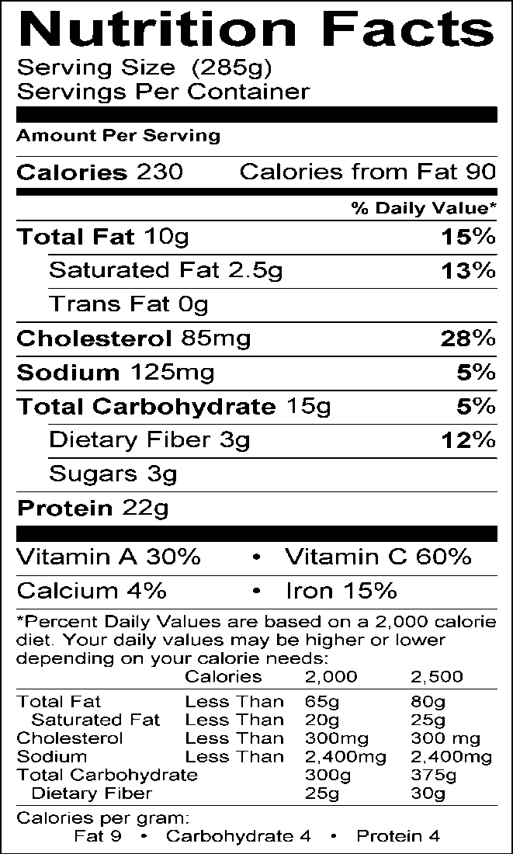
Serving Information
Makes approximately
eight 1-c. servings

Ingredients
1 tsp. canola or olive oil 1 medium onion, diced
1 medium green bell pepper, diced
2 cloves garlic, minced (or ¼ tsp. garlic powder or 1 tsp. bottled pre-minced garlic)
1 Tbsp. chili powder
1 tsp. cumin
⅛ tsp. pepper
1 lb. lean ground turkey breast or extra-lean ground beef
4 c. tomato sauce (reduced-sodium if available)
1 (6-oz.) can tomato paste

Equipment
Large saucepan or pot Measuring cups and spoons Colander (for draining fat) Spatula
Ladle

Directions
- Heat oil in a large pot or saucepan over medium heat.
- Sauté the onion, bell pepper, and garlic until tender and onion is translucent. Add spices and cook for 1 minute.
- Add turkey and cook for 5-7 minutes or until no longer pink.
- Add tomato sauce and tomato paste. Simmer, covered for 20-30 minutes until flavors are blended and chili is thick.
- Ladle into bowls and serve immediately.

Source: Dining with Diabetes WVUES, 2000-present

51

Talking Points

Thick Turkey Chili

When buying ground turkey, be sure to read the label. Some packages may include the skin. Look for lean ground meat or ground turkey breast only. Ground turkey may also take a bit more time to brown and break up into smaller pieces as it cooks. Cook over medium heat and continue to stir with spatula. If lean ground turkey breast is not available, use extra-lean ground beef. Extra-lean ground beef has approximately the same amount of fat as lean ground turkey.

- Adding the spices with the oil and vegetables at the start of cooking brings out the natural flavors and aromas in the spices. Adding them at the end of the cooking process will produce a less flavorful chili.

- The recipe analysis is based on reduced-sodium tomato sauce. Note that sodium content will vary depending on the brand used.

- This chili can be served as a chili in a bowl or as a sloppy joe on a bun. Remember that serving crackers or adding the bun will change the nutritional information by increasing calories and carbohydrates.

- This chili freezes very well and can be portioned into individual serving containers and frozen for up to 6 months.

Turkey Chili Joe 52

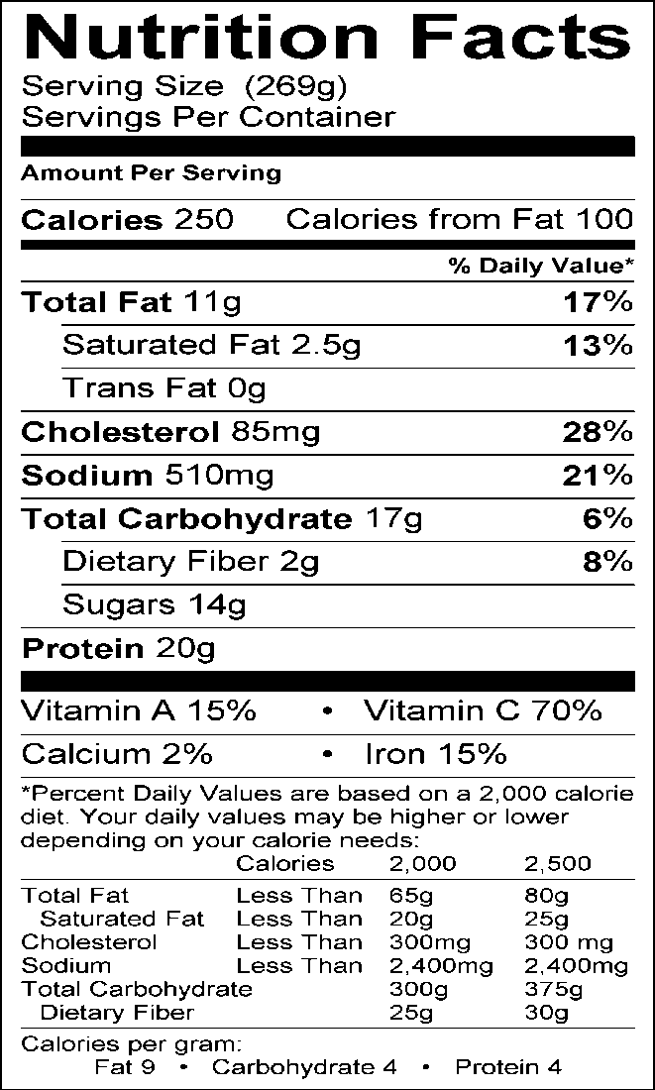
Serving Information Makes approximately 2 servings (one serving = 1¼ cups)

Ingredients
1 tsp. canola or olive oil
½ c. chopped green onions
½ c. chopped green bell pepper
½ lb. lean ground turkey breast
½ c. tomato sauce
½ tsp. sugar
¼ c. catsup
½ tsp. red pepper flakes (optional) 1 tsp. wine vinegar
⅛ tsp. pepper

Equipment
Large skillet or electric frying pan Colander
Measuring cups and spoons

Directions
- Heat oil in skillet or frying pan.
- Sauté the onion and bell pepper until translucent.
- Add turkey and cook for about 5 minutes or until no longer pink.
- Drain off any fat.
- Add all of the remaining ingredients and mix well.
- Simmer for about 15 minutes. Can be served as a chili or sloppy joe on a bun.

Source: Dining with Diabetes WVUES, 2000-present

53

Talking Points

Turkey Chili Joe

You may want to add pepper flakes a bit at a time. For some, it may be a bit too spicy.

- When buying ground turkey, be sure to read the label. Some packages may include the skin. Look for lean ground meat or ground turkey breast only. Ground turkey may also take a bit more time to brown and break up into smaller pieces as it cooks. Cook over medium heat and continue to stir with spatula.

- The recipe analysis is based on low-sodium tomato sauce. Note that sodium content will vary depending on the brand used. Therefore, it is important to read labels.

- While Turkey Chili Joe can be served as a chili in a bowl or as a sloppy joe on a bun, remember that serving crackers or adding the bun will change the nutritional information by increasing calories and carbohydrates.

White Turkey Chili 54

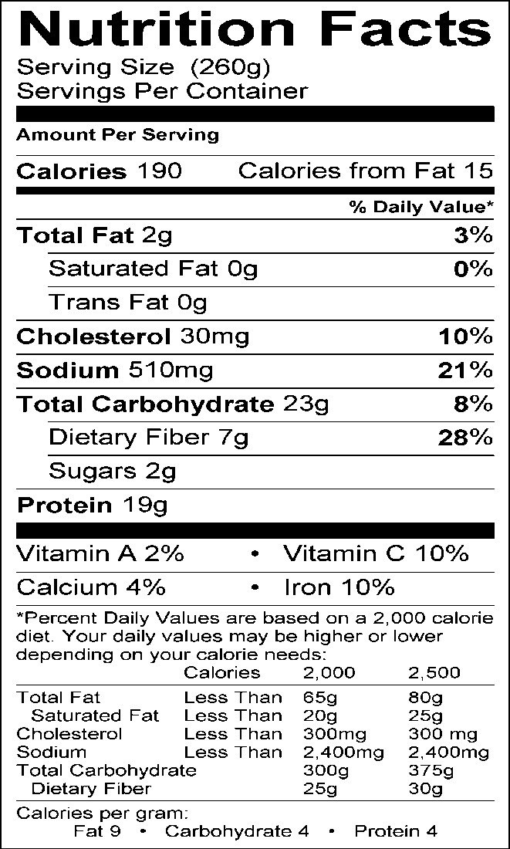
Serving Information Makes approximately twelve 1-c. servings

Ingredients
16 oz. (2 c.) cooked, cubed white turkey breast
2 c. sweet onions, chopped
2-3 garlic cloves, minced
1 Tbsp. olive or canola oil
2½ c. chicken broth (fat-free & low sodium)
2 (15-oz.) cans of cannelloni or great northern beans and drained
2 (15-oz.) cans of cannelloni or great northern beans, drained and mashed
1 (4-oz.) can of chopped green chilies
2 c. canned, drained whole kernel corn
1/2 tsp. salt
1 Tbsp. dried oregano, crushed
1½ tsp. ground cumin
½-1 tsp. chili powder
½ tsp. ground red pepper
½ tsp. freshly ground black pepper

Directions
- In a large heavy saucepan or Dutch oven over medium-high heat, sauté turkey pieces and onion in oil for 8-10 minutes.
- Stir in garlic, cooking just for a minute or two. Stir in broth and the remainder of the ingredients. Bring to a boil, cover, reduce heat, and simmer 20 minutes, stirring occasionally. (You can add an additional ½ c. of broth or so to the two cans of beans to be mashed if utilizing a blender to mash the beans, creating a smoother puree of beans to add to the chili.)
- Serve in soup bowls with toppings of your choice.
Source: Dining with Diabetes WVUES, 2000-present

55

Talking Points

White Turkey Chili

Note that there are 4 cans of beans in this recipe: two are used whole (drained) and two are drained, then mashed. The mashed beans serve to thicken the chili.

