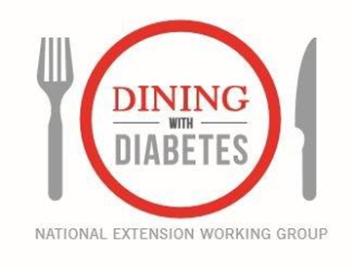
Mission Statement: The National Extension Dining with Diabetes Working Group provides leadership and coordination for unified program delivery and evaluation of Dining with Diabetes.

The mission is moved forward through the leadership of the following support team, subcommittees and their chairs:

Leadership Team: Fran Alloway, Melissa Bardsley, Diana Fair, Stephanie Faroh,
Cindy Fitch, Shari Gallup, Barb Hennard, Lisa Graves, and Dan Remley
Professional Development Subcommittee: Shari Gallup
Curriculum and Evaluation Subcommittee: Stephanie Faroh
New Initiatives Subcommittee: Melissa Bardsley

The following individuals have contributed to the success of the National Extension Dining with Diabetes Working Group:

Ingrid Adams
Lola Adedokun
Fran Alloway
Mandy Armentor
Debbie Baker
Melissa Bardsley
Laura Barr
Debra Berardi
Dianna Bowen
Julie Buck
Cheryl Bush
Patty Case
Terri Crawford
Marilyn Csernus
Marie Economos
Megan Erickson
Diana Fair
Stephanie Faroh
Cindy Fitch
Sue Flanagan
Shari Gallup
Lisa Graves
Barb Hennard
Terrie James
Christine Kendle
Alan Majka
Rose Merkowitz
Jennifer McCaffrey
Krissy Mullenhour
Janet Mullins
Becky Nesbitt
Karen Newton
Kathy Oliver
Dan Remley
Cathy Rogers
Heli Roy
Jenna Smith
Cheryl Spires
Kathleen Splane
Kerri Wade
Patsy Watkins
Kimberly Wilson-Sweebe
Mary Liz Wright
Marjorie Zastrow

