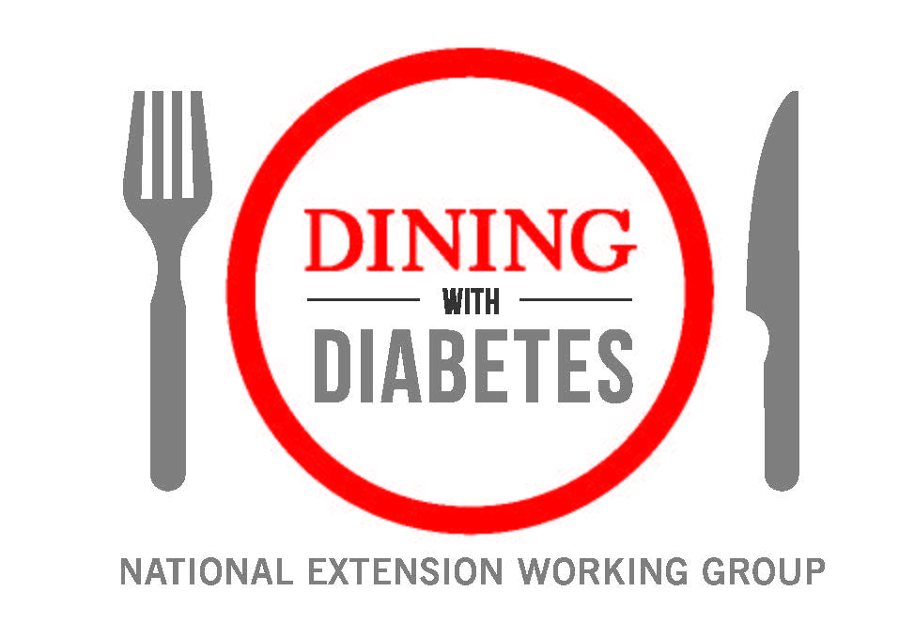
Usage Agreement

Efforts undertaken by the National Extension Dining with Diabetes Working Group (NDWD) have resulted in the development of a curriculum and evaluation for national use by Cooperative Extension. By partnering with the National Extension Dining with Diabetes Working group to deliver the curriculum and evaluation, you are asked to abide by the following terms:
- Rights to the NDWD’s Dining with Diabetes curricula and evaluation cannot be transferred to another entity without first obtaining written permission from the NDWD.

- The NDWD logo must remain on all publications and promotional materials provided, but can be co-branded with other logos.
- The NDWD’s Dining with Diabetes curricula must be used for the sole purpose of providing education for adults at risk of type 2 diabetes, with pre-diabetes, with type 2 diabetes, with other insulin-resistant conditions, or people with other conditions that would benefit from this program, and/or their families and caregivers.

- An Extension Educator/Agent will assume leadership for delivery of Dining with Diabetes, including forming and maintaining a coalition of health professionals, data collection and other assessment, submitting evaluation data, and delivery of the Dining with Diabetes program. If a community partner assists the Extension Educator/Agent, the community partner and Extension Educator/Agent will agree upon who will take primary responsibility for the completion of these program components and related tasks. It is strongly encouraged that you partner with a Registered Dietitian Nutritionist (RD or RDN), Certified Diabetes Educator, or a Registered Nurse who is a diabetes educator when offering this program.

- The Extension Educator/Agent will receive the curriculum and evaluation materials from the NDWD. It is the responsibility of the Extension Educator/Agent to print any paper copies at their own personal expense.

10/2015

