[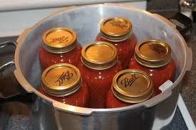](http://www.google.com/url?sa=i&rct=j&q=&esrc=s&frm=1&source=images&cd=&cad=rja&uact=8&docid=YrqF5MGRBqshZM&tbnid=VQT1m6utkbObgM:&ved=0CAUQjRw&url=http://oldworldgardenfarms.com/2013/03/12/growing-a-garden-for-canning-how-to-plan-to-can-and-save-big/&ei=Yq49U6rUD6emygHx_YGgAg&bvm=bv.64125504,d.b2I&psig=AFQjCNEF4KHyClbS4TN_VEO5HvUiRkDUGw&ust=1396637659347646)

[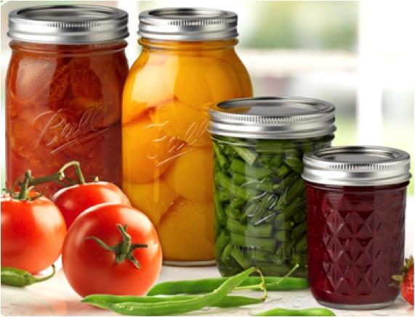](http://www.google.com/url?sa=i&rct=j&q=&esrc=s&frm=1&source=images&cd=&cad=rja&uact=8&docid=vIq7xStXpFeJTM&tbnid=u2gHqxd8i4UhOM:&ved=0CAUQjRw&url=http://heart2heartfarms.com/blog/tag/canning/&ei=xLg9U9PDF-_yyAGDs4D4Cw&bvm=bv.64125504,d.b2I&psig=AFQjCNEF4KHyClbS4TN_VEO5HvUiRkDUGw&ust=1396637659347646).

***Join us for one or all four of the***

***Food Preservation Programs!***

***Preserving the Harvest***

OHIO STATE UNIVERSITY EXTENSION

CFAES provides research and related educational programs to clientele on a nondiscriminatory basis. For more information: http://go.osu.edu/cfaesdiversity.



A Monthly “How To” Home Canning Series



**OSU Extension- Holmes**

75 E. Clinton St, Suite 109

Millersburg, OH 44654

Phone: 330-674-3015

Fax: 330-674-1908

**shumaker.68@osu.edu**

**holmes.osu.edu**

Many new research-based recommendations for canning safer and better quality food at home are available today. It is critical that home canners, beginners and experienced, are aware of and follow the latest USDA guidelines. The advantages of home canning are lost when inappropriate and unsafe procedures are used. Armed with sound information and safe equipment, the harvest of the season is yours to enjoy long into the winter season.

If you're the type of person that likes to develop new recipes this is NOT the time to do it! Canning is not the place for experiments. Always use a tested recipe and we have plenty of them to share. Another thing to remember is that dial gauges on pressure canners should be tested yearly for accuracy.

May- August 2014

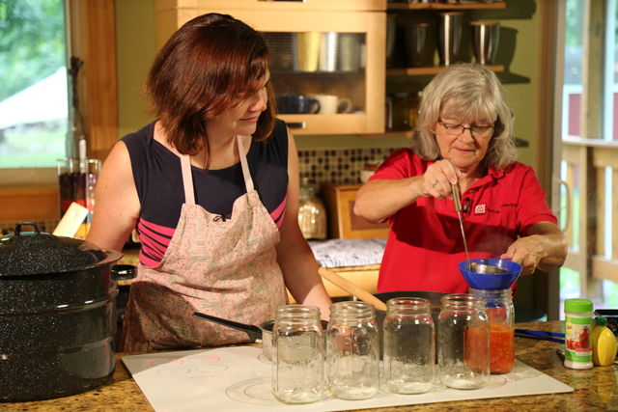

Classes held at the Holmes County Office Building (Old Rodhe’s) in the upstairs meeting room and begin at 6:30 p.m.

Canner testing is available for $5. Call to schedule.

It's home canning time again! For those planning to preserve food at home this summer season, it's also time to check out your equipment. Canning can be a safe and economical way to "put food by" as well as a source of enjoyment and pride for many.

But, there are some basic rules of thumb worth remembering that will help ensure a safe, quality preserved product. When canning low acid vegetables, meat or a combination of vegetables (like spaghetti sauce), a pressure canner is the only way to preserve these foods safely. High-acid foods such as fruits, pickles, salsa, jams and jellies can be safely processed using a boiling water bath canner. It is also recommended that the acidity level of low-acid foods such as tomatoes be raised by adding an acid to the product. This can be accomplished by adding lemon juice or citric acid to the jars.

Learn about how to safely home preserve food using a boiling water bath and a pressure canner. This class is geared to teach those who are new to home canning the basics and provide a refresher to experienced home canners. Participants may also have their pressure canners tested for safety and dial gauge pressure canners tested for accuracy before the programs for a small fee.

***Program Series Details***

Date/ Topic:

Tuesday, May 27– Canning Basics

Tuesday, June 24– Freezing Basics

Tuesday, July 22– Pickles & Salsas

Tuesday, August 26– Canning Meat & Soup

***Programs are 6:30-8:00 p.m** Free and open to the public***

**Location: Holmes County Office Building (Old Rodhe’s)**,

**Upstairs meeting room, 75 E Clinton St., Millersburg, OH 44654**

** This room is only accessible by stairs.

UDSA Complete Guide to Home Canning manual will be available for purchase from OSU Extension- $20 each.

**Home Canning & Food Safety Series**

Name

Address

Phone

Email

I plan on attending:

May 27 Canning Basics

June 24 Freezing Basics

July 22 Pickles & Salsa

August 26 Canning Meat & Soup

*Drop off or mail registration to:*

OSU Extension- Holmes County, 75 E Clinton St, Suite 109, Millersburg, OH 44654

Or call 330-674-3015

OSU Extension: Empowerment Through Education

**Sponsored by OSU Extension- Holmes County**

**Taught by Kate Shumaker, OSU Extension Holmes Co.**

**Family & Consumer Sciences Educator**

**Registration Form**