**SNAP-Ed – Expense Reports for PCard transactions (non-travel purchases)**

*A Workday job aid for creating expense reports for non-travel PCard purchases made by SNAP-Ed employees.*

Table of Contents:

* Before Creating an Expense Report (pg. 1)
* Creating the Expense Report (pg. 2)
* Expense Report Information (pg. 3 – 4)
* [Adding Expense Line(s)](#_Adding_Expense_Line(s)) (pg. 5 – 8)
* Submitting and What to Do After Submission (pg. 9 – 10)
* Workday Term Changes and Worktag Help (pg. 11)

# **Before Creating an Expense Report**

* You cannot create an Expense Report for PCard purchases that are not yet in Workday.
* The University requires PCard purchases to be expensed within 7-10 business days.
* This job aid is specifically **for non-travel purchases**. Expense reports for travel related PCard purchases need to have a Spend Authorization submitted first, similar to the expense report process for mileage reimbursements.

______________________________________________________________________________

**For other job aids and help about new Workday processes, visit the** [**Administrative Resource Center**](https://admin.resources.osu.edu/)

**You can see the ARC’s job aid for creating expense reports for PCard transactions** [**here**](https://admin.resources.osu.edu/workday/workday-for-core-users-finance/create-expense-report-for-credit-card-transactions-non)

# **Creating the Expense Report**

You can get to the Create Expense Report task screen by doing one of the following:

1. On the Workday home screen, click on the Request Travel or Purchase icon
   * 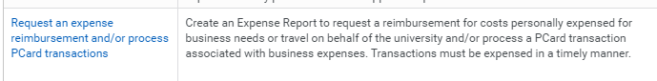On the next screen, click “Request an expense reimbursement and/or process PCard transactions”
2. **OR** Search for “Create Expense Report” in the search bar at the top of the page. Note that you do not have to type in the full phrase in order to search for it (i.e. you could just type in “create expense” and the task should still come up in the results).
   * If the task does not appear in your search results, double check the spelling or click on the “All of Workday” search category on the left side of the page.

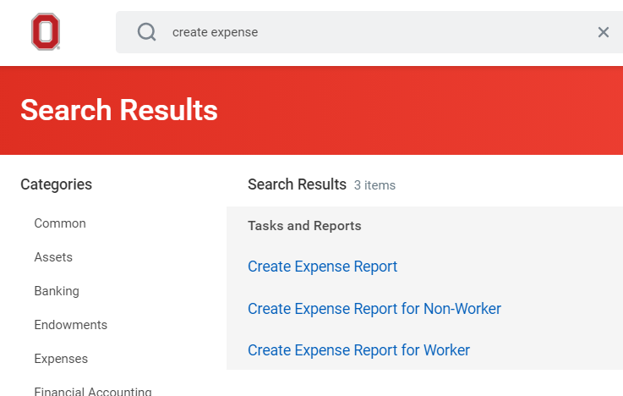

# **Expense Report Information**

**1**

**2**

SNAP-Ed Patrick Conley weekly PCard expense report for OSP card x0000

**4**

**3**

1. Select the button for “Create New Expense Report.”
2. For Memo, enter the following:
   1. SNAP-Ed [Employee Name] weekly PCard expense report for OSP card x[last 4 digits of card #]
3. The Expense Report date should default to the current date.
4. For Business Purpose, select “Non-Travel.” You can either type this in and hit Enter, or by selecting it from the dropdown menu.

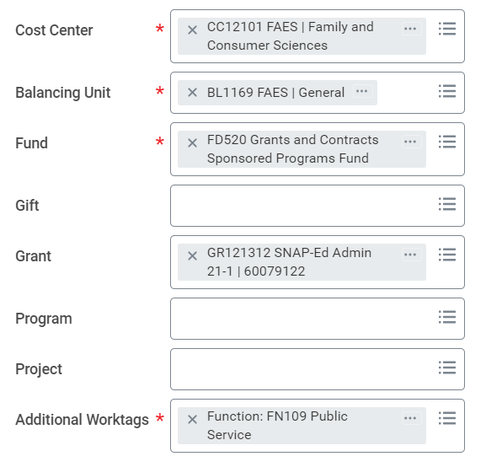

Enter the correct Worktags for your SNAP-Ed region. These should be the Worktags for your SNAP-Ed region.*

* Make sure you are using the correct Cost Center number for your region.
* Make sure that Fund field is **FD520 Grants and Contracts Sponsored Programs Fund**
* Make sure the Grant number is the current number for your region.
* The Gift, Program, and Project fields can be left blank.
* The **FN109** Worktag will default in Additional Worktags. This can be left alone.

*A table with Worktag conversions from the Chartfields used in PeopleSoft will be on the last page of this job aid.

Below the Worktag information, you can select which PCard transactions will be included on the Expense Report. An Expense Report can have multiple transactions on it, as long as they are all non-travel purchases. If you need to submit an Expense Report for any travel PCard purchases, you must create a separate Expense Report.

**Note:** PCard transactions may take 1 – 2 business days before they appear on this page.

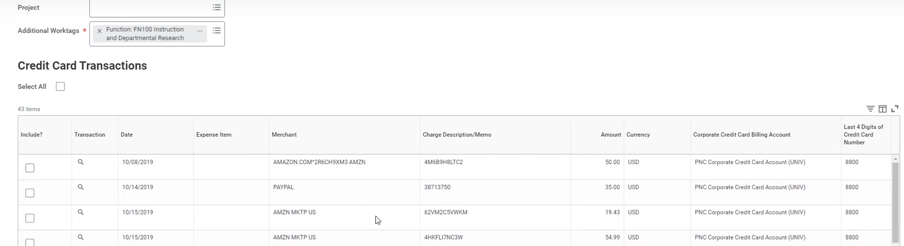

You can select the check box next to “Select All” if you wish to use all current transactions on the Expense Report. Otherwise, check the boxes in the “Include?” column for every transaction you wish to have on the Expense Report.

You can also search for specific transactions using the sort functionality in Workday. You can see how to do this using [this video](https://admin.resources.osu.edu/workday/workday-for-core-users-finance/cardholder-information-session-december-2020) on the ARC website (start at the 7:00 timestamp).

# **Expense Line(s) Information**

After hitting OK on the previous page, an **Expense Report #** is created. Make sure to copy down this information for your records.

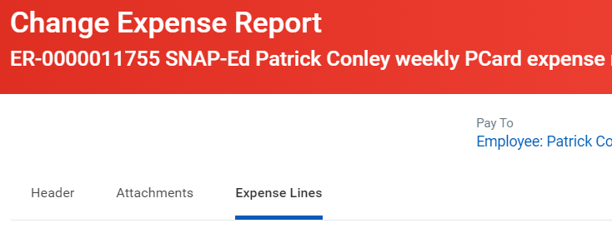

Since you selected one or multiple transactions on the previous page, Expense Lines will already be present on this page.

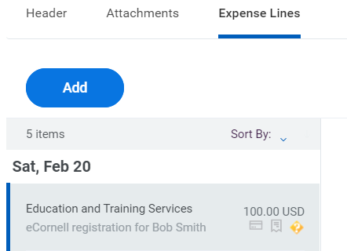

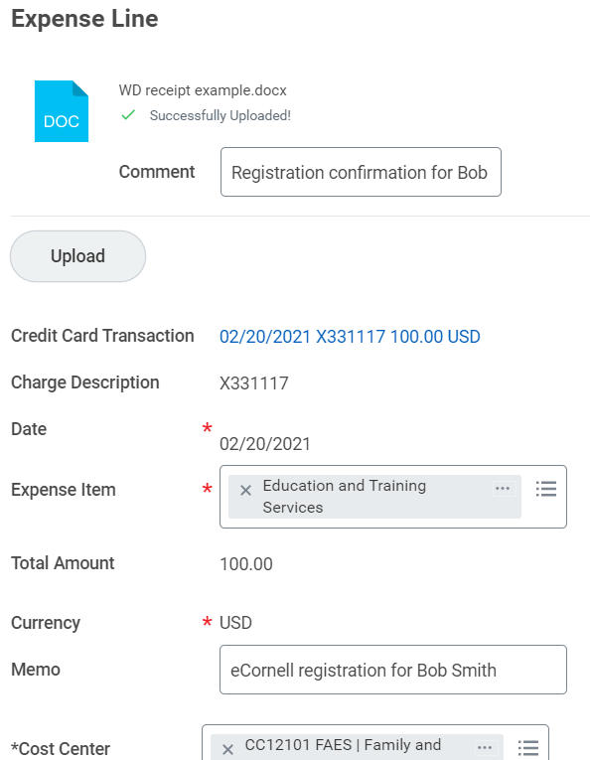

**3**

**6**

**5**

**4**

**2**

**1**

1. You will need to attach a receipt **AND** a copy of your purchase approval from your respective Regional Program Specialist. Include a comment briefly explaining what both attachments are. Make sure to check the “Receipt Included” box in the right side of the page.
2. This shows the date, memo, and amount of the transaction.
3. The date should default to today’s date.
4. For **Expense Item**, select what best fits the transaction.
5. The amount requested should be equal to the amount from the credit card transaction line.
6. For **Memo**, be as descriptive as possible.
   * For example, if buying food for a cooking demonstration: Food for SNAP-Ed cooking demo in X County led by [Employee name]

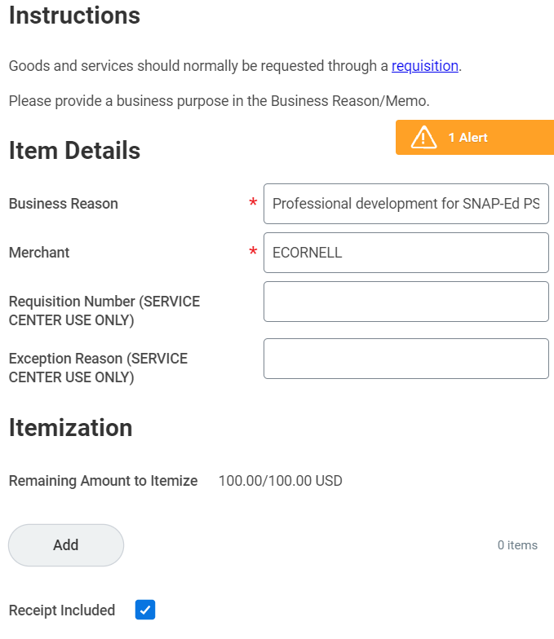

**1**

**2**

1. For **Business Reason**, write what business purpose this transaction was for.
   1. The Administrative Resource Center recommends including the who, what, why, when of the transaction.
   2. This would include things like who the purchase is for, what the purpose of it is, why it was necessary to make the purchase, and when the purchase was made.
2. **Merchant** should default in based off the credit card transaction.

# **Submitting the Expense Report**

If you have added all the information for all expense lines on the report, you are ready to Submit the Expense Report. Before doing so, check that all information is correct by:

* Checking the Worktags are correct for the expense line(s).
* Checking that all the information is correct on the expense line(s).
* Checking for any errors or alerts on the expense line(s).

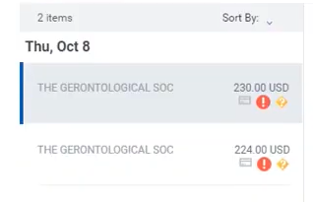

On the left side of the page, you will see a quick snapshot of each expense line. This will also show any errors or alerts that might be on each page. For this example, there is an error on both expense lines that must be corrected before submission.

When you are done checking the Expense Report, hit **Submit**.

# **What to Do After Submission**

Before clicking away from the submission confirmation screen, ***copy down your Expense Report number***. This ER# is helpful for tracking purposes and can assist your regional Office Associate or others when reconciling the budget.

On the confirmation page, you can review the details of the ER you’ve just submitted under **Details** or review the next steps for approval under **Process**.

If you navigate away from this page, you can also check the Archive tab in your Inbox to find previously submitted items.

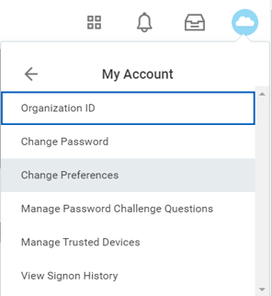Your Expense Report will be reviewed, and if something is found to be incorrect or needs updating, it will be sent back to you. Workday should give you a notification on your Home page if this happens. It is also recommended to make sure you have email notifications turned on to “immediately.” You can check and change your notification preferences by clicking the profile icon in the upper right corner of the Workday homepage (blue circle with cloud icon shown here), clicking on My Account, and then clicking on Change Preferences. More details can be found here: [Changing Notification Preferences](https://admin.resources.osu.edu/workday/workday-for-employees/changing-notification-preferences)

# **Workday Term Changes**

|  |  |  |
| --- | --- | --- |
| PeopleSoft Term | → | Workday Term |
| eTravel Request | → | Spend Authorization |
| T# | → | Spend Authorization # |
| Travel Reimbursement | → | Expense Report |
| Org | → | Cost Center |
| Project # | → | Grant # |

# **Worktag Help**

**Orgs to Cost Center #s:**

|  |  |  |  |
| --- | --- | --- | --- |
| Region | PeopleSoft | → | Workday |
| Admin | 55900 | → | CC12101 |
| Central | 55905 | → | CC12063 |
| Northeast | 55901 | → | CC12077 |
| Northwest | 55907 | → | CC12072 |
| Southeast | 55904 | → | CC12074 |
| Southwest | 55906 | → | CC12081 |

**Grant #s:** Refer to your Regional Program Specialist for your current Grant number.

* SNAP-Ed uses a new Grant number every 9 month (October – June) and 3 month (July – September) period.